- Strana 45 & 46 – ne secam se da li imamo custom attribute. Ako se ti ne secas toga reci mi da izbacim sve iz xml primera I teksta koji prica o custom attributes.
- Obrisao sam “detect.running.engine.instances” property iz word guidea, neka ostane u xml guide da mi znamo da je tutj da postoji
- Strana 61: fali nam primer za compbden dimension lookup. Ja sam dodatno objasnio textualno. Ako imas primer mozes da ga stavis u “\demo_sales\examples\”. Ja se secam ideje da se za N dimenzija uradi lookup odjednom, samo se ne secam da kada je N=3 za tri dimenzije, da li ta Mapa vraca 3 surrogate keys koji su nekako delimited?

Ostalo je sve ready sto se mene tice, sve sam obojio u crno, ono sto je sredjeno. Skinucu official veruiju software uskoro da znas da sam ja…

StreamHorizon Guide
Version 3.x.x

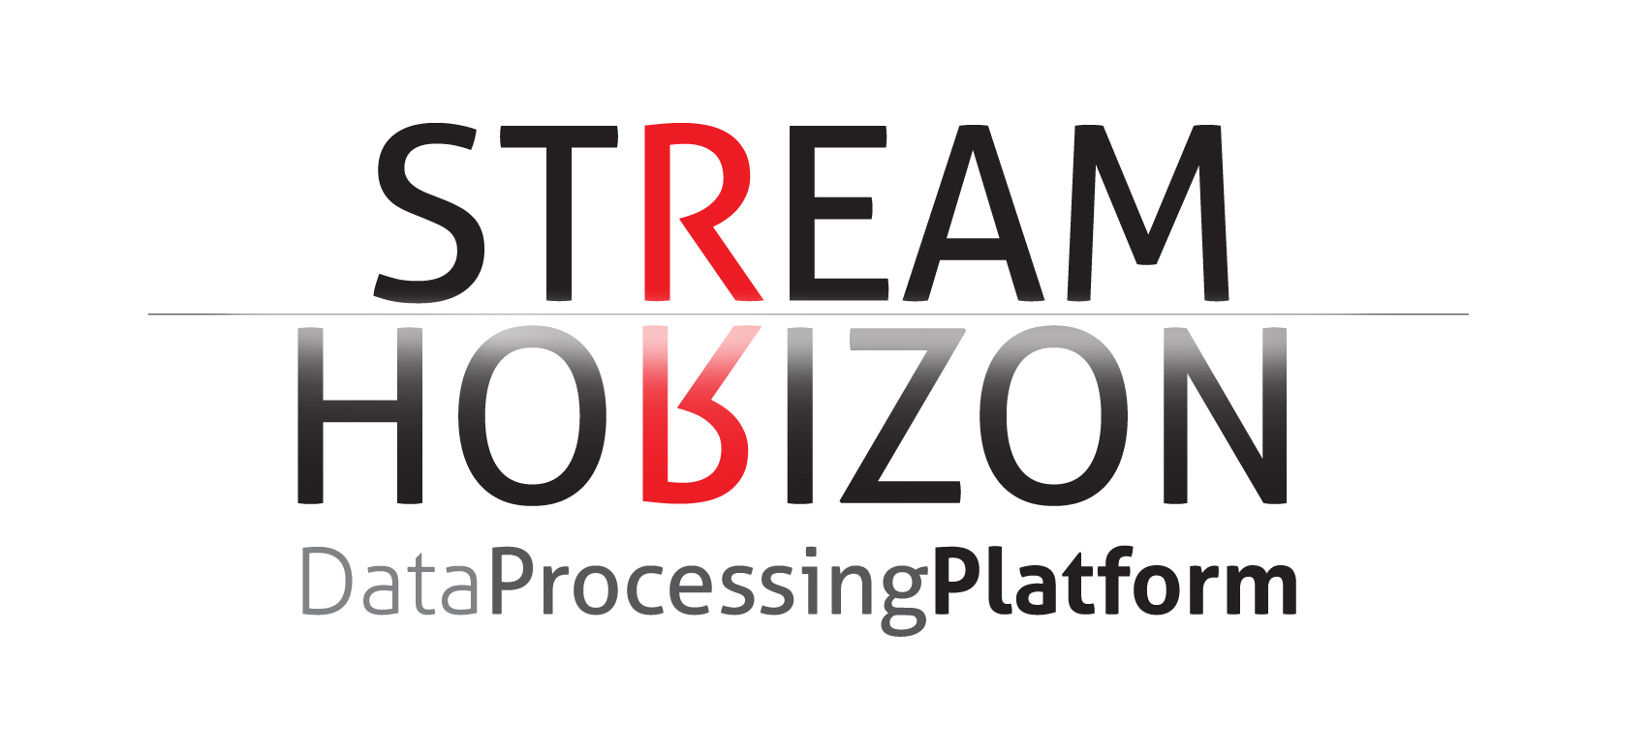

Table of Contents
- Getting Started 6
About this Guide 6
Installation requirements 6
StreamHorizon directory structure 6
StreamHorizon configuration files 7
Engine configuration file (engine-config.xml) 7
Logging configuration 8
Caching configuration (In-memory data grid) 8
- Master database connectivity 9
Relational targets 9
Multiple master databases 9
Master database connection 9
Multiple database targets 10
<jdbcPoolSize> 10
<databaseStringLiteral> 11
<databaseStringEscapeLiteral> 11
- Context variables 12
Custom context variables 12
Using custom defined (and global) context variables (part 1) 13
Global context variables 14
Using custom defined (and global) context variables (part 2) 16
- Parameter substitution 17
Database string literals & string escape literals 19
- Defining dimensions & caches (entity relationships, mappings & data integrity) 19
Establishing a common dictionary 19
Dimension - example 20
Dimensional types (Type 1, Type 2, Insert only) 22
Custom dimension type 24
Other dimensional settings 25
- Source & target connectivity 26
Feed definition (ETL flow definition) 26
ETL Streams – complex & Integrated ETL flows 26
DB Threadpool is just a generic pool (OLAP integration example) 28
Source type definition 29
File & Directory – processing input file feeds 29
Relational database source connectivity 30
Thrift based connectivity 31
Middleware messaging source connectivity 32
Hadoop source connectivity 32
Custom source connectivity 32
Target type definition 32
Relational database target connectivity 33
File & directory target connectivity 35
Hadoop target connectivity 36
Source format definition 37
File header & footer 38
File processing modes 40
Extracting data from file Name 43
Processing parallelism definition 44
Target format definition 45
Custom ETL logic & custom context parameters 46
- Processing events 50
Using processing events for error handling 51
Using processing events in case of successful ETL completion 51
Using processing events irrespective of completion status 51
using processing events for gathering metrics & perfomrance statistics 54
- Logging 57
- Archive & error directory 58
- General properties <properties> 59
- Flushing caches via HTTP 65
- Monitoring via jvm 66
- Emailing & Alerting 67
- Startup and recovery 68
- Clustering StreamHorizon (Local cluster deployment & OTHER) 69
StreamHorizon instances are independent 69
StreamHorizon instances share same source directory 69
StreamHorizon instances share dimension caches 69
- Deployment strategies 74
Deployment flavours of ETL & DB threadpools 74
Deployment flavours of ETL & DB threadpools 74
ETL GRID deployments 77
ETL GRID cohabited with compute grid 78
- Performance tuning 81
Deployment types 81
What is desired threadpool size? 81
Right balance between ETL & DB threadpools 82
Bulk load mode - ETL & DB threadpools (tuning tips) 82
Dedicated ETL & Dedicated DB loader tuning tips 82
Increasing Stream Horizon demo parallelism 83
JDBC mode tuning 83
I/O read & write and CPU tuning 83
Cpu utilisation 84
Dimensional Caches 84
Other critical tuning parameters 85
Oracle subsecond query latency and aggregations 87
Oracle Benchmarks 87
Indexing with MSSQL - MSSQL Benchmarks 88
- metrics & auditing framework 89
Gathering metrics via streamhorizon events 89
Metrics database framework 89
Metrics database views 90
Few very important facts 91
Customize metrics & logging 91
Checking throughput of your server for MySQL database 91
Realistic Testing 91
Throughput guidelines 92
Realistic data 92
Tuning StreamHorizon 93

Getting Started

About this Guide
This document elaborates in detail about features of StreamHorizon Data Processing Platform.
NOTE: If you are not familiar with StreamHorizon architecture and terminology we strongly recommend you to read single chapter guide “StreamHorizon in a nutshell (Quick Start)”. That guide elaborates in detail how to build Data Warehousing/Data Integration project from scratch and introduces reader to the architecture of StreamHorizon platform. Guide is available for download at Resources & Downloads page of StreamHorizon website (it is also distributed with Sales Demo of StreamHorizon).
Condensed version of “StreamHorizon in a nutshell (Quick Start)” document can be found in file streamHorizonQuickXMLTutorial_engine_config.xml this file/document is supplied with installation of StreamHorizon and will be sufficient for experienced IT staff to quickly master most of StreamHorizon functionalities. This document is located in $ENGINE_HOME/config/streamHorizonQuickXMLTutorial_engine_config.xml
While reading this guide you should try to (if required) check following sources of configuration examples:
- $ENGINE_HOME/config/streamHorizonQuickXMLTutorial_engine_config.xml
- $ENGINE_HOME/demo_sales/mssql/engine-config-JDBC-example.xml
- $ENGINE_HOME/demo_sales/mssql/engine-config-BULK-INSERT-example.xml
- $ENGINE_HOME/demo_sales/oracle/ext-table-deploy/engine-config-example.xml
- $ENGINE_HOME/demo_sales/oracle/jdbc-deploy/engine-config-example.xml
- $ENGINE_HOME/demo_sales/oracle/pipe-deploy/engine-config-example.xml

Listed xml files contain examples of all basic StreamHorizon deployment configurations and settings.

Installation requirements
Installation of StreamHorizon platform is simple and easy. Download installation archive (available at www.stream-horizon.com), uncompress it to your local hard drive in the directory of your choice (we will refer to this directory as $ENGINE_HOME from now on).
There are very few minimum requirements that need to be met in order to run StreamHorizon.
- Mainstream operating system (Linux, Windows, Solaris)
- JDK 1.7+ (we recommend Oracle HotSpot)
- Database that supports JDBC (most likely data produced by StreamHorizon will go into some kind of database). This is not hard requirement if you only want to produce output files.
NOTE: Even if you intend to run multiple (clustered) StreamHorizon instances there is no need to install binaries more than once per physical machine.

StreamHorizon directory structure
After uncompressing StreamHorizon archive to $ENGINE_HOME directory you will see following directory structure inside:
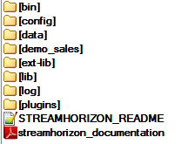

Directory name | Purpose
$ENGINE_HOME/bin/ | All startup scripts should be placed here. There are few default scripts that can be used for starting single instance. If you are adding new startup scripts always place them in this directory.
$ENGINE_HOME/config/ | All configuration files are here:  - What engine should log and at what level  - Here is where you copy your main engine configuration file(s)  - Configuration for clustered caches used by engine
$ENGINE_HOME/data/ | This is engine private directory used for housekeeping. You should not add, delete or modify anything inside this directory.
$ENGINE_HOME/demo_sales/ | Demo feature showing capabilities of engine (performance and functionality).
$ENGINE_HOME/ext-lib/ | Additional dependencies needed by plugins. Compiled StreamHorizon plugins can also be placed here, in their own jar files.
$ENGINE_HOME/lib/ | External dependencies needed by engine are placed here. You should not add, delete or modify anything inside this directory.
$ENGINE_HOME/log/ | Engine log files will be found here.
$ENGINE_HOME/plugins/ | Java plugins. Plain *.java files can be placed here and engine will compile and use them (when configured to do so).

StreamHorizon configuration files
There are multiple configuration files available and all of them can be found in $ENGINE_HOME/config/ directory.

Engine configuration file (engine-config.xml)
The main configuration file for StreamHorizon engine is $ENGINE_HOME/config/engine-config.xml
This file describes to StreamHorizon engine where to find input data, how to process it and where to send output results.
The engine-config.xml allows user to:
- Set any number of ETL processing threads and DB processing treads and achieve high data throughput
- Perform pre-processing, post processing, header & footer processing, data record processing of file, message, SQL query, any Thrift, Hadoop/HDFS and relational database feeds (sources).
- Ability to make external SQL or OS script at any point of your ETL execution.
- Ability to customize in Java any segment with your ETL logic
- Ability to recover & cleanup at startup

Logging configuration
Logging is configured in $ENGINE_HOME/config/logback.xml
Please refer to logback (http://logback.qos.ch/manual/configuration.html) documentation for further details about how to change logging levels.

Caching configuration (In-memory data grid)
StreamHorizon uses clustered cache to avoid unnecessary trips to datasource (usually database). It is possible to choose between two clustered cache technologies: Infinispan and Hazelcast. By default, Infinispan is used and this is recommended.
Configuration files for each of these cache technologies can be found in $ENGINE_HOME/config/
Please refer to appropriate online documentation to understand how to tune these libraries.

Master database connectivity

Relational targets
Most of StreamHorizon deployments will utilize relational database (Data Warehouse, ODS, Data Mart, MIS or OLTP) as a target where output of ETL transformations is persisted and where referential data is held. Term “Master Database” refers to referential (or other metadata) data store which has all referential, lookup, dimensional and other data which will be used during ETL processing (forming dimensional & lookup caches for example). The Master Database connection can also be used for inserting data into fact (or other) tables by either ETL or DB threads.
Note: Master database configuration isn’t mandatory to be configured. Hadoop deployments, sole messaging deployments and deployments which process files (as input as well as output) do not require setup of Master Database Connectivity. However, such deployments are rare in practice.

Multiple master databases
StreamHorizon supports connectivity to multiple referential data sources (multiple master databases) via dimensional caches. This can be achieved by Custom dimension implementation in Java (see chapter “Defining Dimensions & Caches”). This enables user to query any referential data source like ActiveDirectory, SOAP or any other data source and to utilize it to form dimensional caches. All that is required is that user implements interface in Java which can form cache by querying any arbitrary data source.

Master database connection
StreamHorizon instance is designed to have single Master Database definition. This effectively means that one database can be Master Database of a given StreamHorizon instance. Connectivity to multiple databases may be achieved by using DB links, synonyms or customised dimensions.
Configuration file ($ENGINE_HOME/config/engine-config.xml) should contain following elements in order to provide master database connectivity:
- <connectionProperties>
- <databaseStringLiteral>
- <databaseStringEscapeLiteral>
Example of correctly configured master database settings (for various database vendors) can be found in:
- $ENGINE_HOME/demo_sales/oracle/jdbc-deploy/engine-config-example.xml
- $ENGINE_HOME/demo_sales/oracle/ext-table-deploy/engine-config-example.xml
- $ENGINE_HOME/demo_sales/oracle/pipe-deploy/engine-config-example.xml
- $ENGINE_HOME/demo_sales/mssql/engine-config-example.xml
Example:
<connectionProperties>
<jdbcUrl>jdbc:oracle:thin:@localhost:1522:orcl</jdbcUrl>
<jdbcUserName>sh</jdbcUserName>
<jdbcPassword>sh</jdbcPassword>
<jdbcPoolSize>100</jdbcPoolSize>
</connectionProperties>
<databaseStringLiteral>'</databaseStringLiteral>
<databaseStringEscapeLiteral>''</databaseStringEscapeLiteral>

Multiple database targets

- By defining multiple feeds <feed> element for StreamHorizon instance you will be in a position to define multiple <target> elements for every feed which can be separate database entities.
- Single StreamHorizon instance can also talk to multiple master databases if you set your master database to have synonyms or database links to another database instances.
- If you deploy more than one StreamHorizon instance you can ensure that your StreamHorizon software stack can talk to multiple master databases.

<jdbcPoolSize>
Element of <connectionProperties> setting determines number of total JDBC connections against target database. Note that this element is in use in JDBC, pipe and bulk load operation mode of StreamHorizon.
It is crucial that sufficiently large number of connections is allocated. This ensures that connections are not reused (by the connection pool) between data processing threads of StreamHorizon. Reuse of connections will unnecessarily reduce throughput of StreamHorizon.
The <jdbcPoolSize> setting must be integer equal or greater than:
jdbcPoolSize = number of dimensions defined in your target database +
number of your ETL threads <etlProcessingThreadCount> +
contingency of 10 additional connections
Example: if you have 10 dimensions in your model and 50 ETL threads < etlProcessingThreadCount> and 50 DB threads <bulkLoadProcessingThreads> inserting into fact table, connection pool should have minimum of 10+50+50=70 connections configured. For contingency set this parameter to 10+50+50+10=80. It is important to avoid reuse of JDBC connections by connection pool of fact loader processes as this can be detrimental for performance.
StreamHorizon engine will not start up and will log error message in case you do not allocate JDBC pool with adequate size.
NOTE: If you run DB load using MSSQL and BULK INSERT statement you will not need to add connections for DB loaders into your total <jdbcPoolSize> size. Reason being that these connections are made externally by Windows batch file (not by StreamHorizon). Same reasoning applies if you are using Oracle database in pipe mode.

<databaseStringLiteral>

Configuration property <databaseStringLiteral> will be used by StreamHorizon to enclose string values passed to the database. For most of databases this value is single quote, and this is the default value provided in config files.

Example:

If StreamHorizon has following SQL statement in config file:

<insertSingleRecord>
insert into dimensionTableName1(dimensionSurrogateKey, tableAttribute1) values (dimensionSequenceName.nextval,'${dataAttributeName_1}')
</insertSingleRecord>

If value of context variable dataAttributeName_1 is AAA for example, StreamHorizon will substitute AAA with ‘AAA’ before it executes SQL statement above against database. This is, of course, case when <databaseStringLiteral> value is set to single quote:

<databaseStringLiteral>’<databaseStringLiteral/>

Arbitrary example of substituted SQL insert statement by StreamHorizon could be:

<insertSingleRecord>
insert into dimensionTableName1(dimensionSurrogateKey, tableAttribute1) values (dimensionSequenceName.nextval,'AAA')
</insertSingleRecord>

<databaseStringEscapeLiteral>

If database string contains <databaseStringLiteral/> for example, and if string which need to be passed to the database should have value AA’A, such string will need be adequately escaped. Most of databases escape string literals with double quote. This means that string passed to the database (by StreamHorizon) need be ‘AA’’A’ in order for database to store string value AA’A in the table.

For example given above <databaseStringEscapeLiteral> needs to be set to two consecutive single quotes:

<databaseStringEscapeLiteral>’’ <databaseStringEscapeLiteral>

Context variables

StreamHorizon ‘context variables’ (or ‘context attributes’) can be used to read value of a particular variable, in all statements and script invocations. For example, feedProcessingThreadID or feedInputFileName are variables reserved by StreamHorizon, they hold value of ETL thread and file name which given ETL thread is currently processing. Every ETL thread has a unique id, during the lifecycle of the ETL thread; thread will process more than one file feed which means that feedInputFileName will always have value populated with name of the file which ETL thread is currently processing.

After processing of given file is done and before new feed file is allocated to given ETL thread, variable feedInputFileName will hold value of the last file processed by the thread. This applies to all context variables, until they get new value allocated their value is the last good value they have had. This is useful behaviour as for example if you create your own attribute and implement it as a counter or a sequence you can always query current value of it.

Note: Context variables is interchangeable term with ‘context attributes’

Context variable types:
- Global context variables - StreamHorizon pre-reserved context variables
- Custom context variables - Context variables defined by you

Custom context variables

Custom context variables are defined in configuration file (engine-config.xml). Any name given to:
- sourceFormatDefinition or targetFormatDefinition which define feed input and output attributes become implicitly custom context variables.
- Name given to dimension in dimensional definition implicitly becomes context attribute.
- It is possible to define custom context attributes by providing implementation for any of StreamHorizon plugins

NOTE: Custom context variable name cannot be same as global context variable name (list of which is supplied below). Global context variables are reserved by StreamHorizon and cannot be overridden by the user of StreamHorizon platform.

Examples of definition of custom variables in configuration file:

All underlined attribute names for a given sourceFormatDefinition and targetFormatDefinition are treated by StreamHorizon as custom context attributes

<header process="normal">
<attributes>
<attribute name="bookingDate" />
</attributes>
</header>
<data process="no_validation">
<attributes>
<attribute name="productName" />
<attribute name="productModel" />
<attribute name="productCategory" />
<attribute name="productCost" />
.
.
.
</attributes>
</data>
<footer process="strict">
<attributes>
<attribute name="fileRecordCount" />
</attributes>
</footer>

Dimension name in dimension definition is also considered to be custom context variable

<dimensions>
<dimension name="employee_dim" type="INSERT_ONLY">
…
…
</dimension>
</dimensions>

Using custom defined (and global) context variables (part 1)

Global context variables are defined by StreamHorizon; their values are maintained (updated) by StreamHorizon engine.

Custom defined context variables defined by end user in engine-config.xml are maintained (updated) by StreamHorizon. Custom defined context variables are (usually) attributes of data sources (file feeds etc) and dimensions (caches).
Custom defined context variables defined in user provided StreamHorizon plugins must be maintained in those plugins.

Usage of global context variables is shown in next section of this document and is mainly used for parallelism (avoiding locking by using partitioning) and for logging of server metrics, please see chapter “USING CUSTOM DEFINED (AND GLOBAL) CONTEXT VARIABLES (PART 2)” section below.

Processed input data is usually transformed into fact table data. Data is delivered via JDBC insert statements or as bulk files (which also have format (same attributes) of fact table). StreamHorizon can also deliver any flat file format which can be used for other purposes rather than being inserted into database.

Notice that output format is defined (implemented) by simply using context variables (both custom and/or global) which are available.

<targetFormatDefinition>
<attributes>
<attribute name="dimension.employee_dim" type="int" />
<attribute name="dimension.customer_dim" type="int" />
<attribute name="bookingDate" type="int" />
<attribute name="feed.priceAfterDiscount" type="float" />
<attribute name="feed.saleCosts" type="float" />
<attribute name="feedProcessingThreadID" type="int" />
<attribute type="string">-1</attribute>
</attributes>
/targetFormatDefinition>

Explanation of xml snippet:

- Context attribute dimension.employee_dim returns key of dimensional lookup for dimension defined with name “employee_dim”.
- Context attribute “bookingDate” is defined in feed header (please see engine-config examples) and is used as attribute in output format.
- Context attributes defined in body of the feed can be referenced as feed.attributeName, for example feed.priceAfterDiscount. This is commonly used for measures as measures (unlike dimensional attributes) are not transformed into surrogate keys, they are rather (usually) mapped from feed straight into output.
- Global context attribute can be included in output feed simply by stating global attribute name like feedProcessingThreadID in example above. This can be later used to ensure that bulk files target different partitions of fact table and thereby avoid locking and achieve high throughput.
- Hardcoded values can also be passed as attributes, in example above -1 value is passed to output format as ‘hardcoded value’.

Global context variables

Global (implicit) context variables are very simple extension points of StreamHorizon engine. They can originate from StreamHorizon engine itself (implicit context attributes) and from Java plugins provided by users.
Context variables can be used in engine configuration files and in Java plugins.
Some variables are available only during execution of ETL threads; some are available only during execution of DB threads and some attributes are available in all cases.
Context variables can be used in engine configuration file by reference – enclosed in ${ and } characters. Engine will recognize these and replace them with appropriate values during execution. For example ${engineInstanceStartTimestamp} will always be replaced with timestamp when that particular StreamHorizon engine instance was started (Unix timestamp).
Java plugins get all the context variables passed as one of parameters passed to their methods and they can change existing attributes or add new ones.
If some variable is not available then NULL value will be passed to all SQL commands using it and Java NULL value will be passed to all Java plugins trying to look it up.
Usage:

Global (or implicit) context variables are created at startup and are defined by StreamHorizon engine. They are useful for processing and metrics gathering.

For example, if you subpartition or partition your fact table you can always use feedProcessingThreadID (ETL thread id) or bulkProcessingThreadID context variables to ensure that every thread is writing to its own partition/subpartition. This enables you to avoid locks and achieve maximum throughput (parallelism) for your ETL.

Some attributes are useful for metrics gathering, metrics which come with Sales Demo (sh_* views and tables) are using global context variables like feedInputFileProcessingStartedTimestamp and feedInputFileProcessingFinishedTimestamp to calculate throughput/latency of StreamHorizon engine.

Global Context variables are printed on the console and in log file at StreamHorizon startup.
Implicitly provided context attributes are:
- engineInstanceStartTimestamp – startup time of StreamHorizon instance (Unix timestamp)
- engineInstanceIdentifier – if running in local cluster mode (multiple instances on single server), every StreamHorizon instance will have its own ID (zero indexed integer number)
- bulkProcessingThreadID- unique ID of DB thread (DB threads usually invoke stored procedures or executables to load bulk files into database. Every bulk thread will have assigned unique identifier (non-negative integer value) per StreamHorizon instance
- bulkProcessingPartitionedThreadID – Applicable only when configuration property bulk.load.threads.partition.count is set to non-negative integer number. Applicable only for DB threads. Property bulk.load.threads.partition.count defines number of bulk partitions. All DB threads will be assigned into one of partitions in range 0-( bulk.load.threads.partition.count-1). This context variable will have value of partition assigned to current DB thread.
- feedProcessingThreadID –unique ID of ETL thread ID (per StreamHorizon instance)
- multiInstanceBulkProcessingThreadID - ID of DB thread which is guaranteed to be unique if you run StreamHorizon in local cluster mode (multiple instances of StreamHorizon) – (non-negative integer value). Every DB thread in every StreamHorizon instance in that cluster will have unique identifier
- multiInstanceFeedProcessingThreadID - ID of ETL thread which is guaranteed to be unique if you run StreamHorizon in local cluster mode (multiple instances of StreamHorizon). Every ETL thread in every StreamHorizon instance in that cluster will have unique identifier
- feedInputFilePath – path and name of feed files (feed files are located in source folder-as configured by the user)
- feedInputFileName – name of feed files file which is currently processed by given ETL thread
- feedInputFileReceivedTimestamp – when was feed file persisted by data producer (application which creates feed files which are consumed/processed by StreamHorizon)
- feedInputFileReceivedDateTime – same as above in datetime format (dd/MM/yyyy hh:mm:ss.SSS)
- feedInputFileProcessingStartedTimestamp – timestamp of start of processing of given file by assigned ETL thread (Unix timestamp)
- feedInputFileProcessingFinishedTimestamp – timestamp of end of processing of given file by assigned ETL thread
- feedInputFileProcessingStartedDateTime – same as above in datetime format (dd/MM/yyyy hh:mm:ss.SSS)
- feedInputFileSize – size of currently processing feed file (in bytes)
- feedBulkLoadOutputFilePath – absolute file path of bulk file which is currently being generated by StreamHorizon
- bulkFilePath – absolute file path of bulk file which is currently being processed by StreamHorizon engine
- bulkNamedPipePath – available only in PIPE mode. Holds absolute file path to the named pipe being currently used to write output to
- bulkFileAlreadySubmittedForLoading – can be T or F depending whether bulk file currently being processed was already processed by this StreamHorizon engine in past. This tracking is only available if explicitly turned on.
- bulkFileName – name of bulk file generated by StreamHorizon. Note, this attribute has value even if StreamHorizon operates in mode when it doesn’t produce batch files (like pipe, JDBC mode etc). No bulk files are created in any other processing mode except bulk (<bulkLoadDefinition outputType="file">)
- bulkFileReceivedForProcessingTimestamp – last modified timestamp of currently processed bulk file
- bulkFileProcessingStartedTimestamp – timestamp of start of processing of bulk file by DB thread
- feedInputFileJdbcInsertStartedTimestamp – start of processing of input file by ETL thread (operating in JDBC mode). If StreamHorizon is processing in non JDBC mode, for example in bulk loading mode parameter feedInputFileProcessingStartedTimestamp should be used as start timestamp of processing.
- feedInputFileJdbcInsertFinishedTimestamp - finish of processing of input file by ETL thread (operating in JDBC mode). If StreamHorizon is processing in non JDBC mode, for example in bulk loading mode parameter feedInputFileProcessingFinishedTimestamp should be used as finish timestamp of processing
- bulkFileProcessingFinishedTimestamp – finish timestamp signifies end of processing of bulk file by DB thread
- bulkCompletionProcessingSuccessFailureFlag – flag has value F in case of Failure and flag S in case of Successful processing of bulk file (this is processing performed by DB thread(s))
- bulkCompletionProcessingErrorDescription – in case when bulkCompletionProcessingSuccessFailureFlag has value F, this attribute will be populated with exception message which has caused processing failure. Failed feed file will be moved from ‘source’ into ‘error’ rather than ‘archive’ directory.
- feedCompletionProcessingSuccessFailureFlag - flag has value F in case of Failure and flag S in case of Successful processing of feed file (this is processing performed by ETL thread(s))
- feedCompletionNumberOfTotalRowsInFeed – while processing input feeds (files) ETL thread counts number of records processed. At completion of processing of files this attribute stores count of records processed by ETL thread for given feed file (or any other source data entity in case that source isn’t file but database or message queue)
- feedCompletionProcessingErrorDescription – in case when feedCompletionProcessingSuccessFailureFlag has value F, this attribute will be populated with exception message which has caused processing failure. Failed feed file will be moved from ‘source’ into ‘error’ rather than ‘archive’ directory.

NOTE: Majority of listed global context variables are used in Demo Sales engine-config*xml files which are provided with install. They are predominantly used for achieving parallelism (partitioning) and for metadata (processing statistics) logging (please see sh_* views and tables and config files for more details).

Using custom defined (and global) context variables (part 2)

Examples of using global variables with StreamHorizon events in Sales Demo sample files:

Example of using global context variables to call Oracle procedure named log_sh_metrics_bulk. Procedure accepts global context variables as parameters (which are subsequently inserted into sh_metrics table by stored procedure):

<afterBulkLoadCompletion>
<command type="sql">
CALL log_sh_metrics_bulk('server_1',${engineInstanceIdentifier},${engineInstanceStartTimestamp},'afterBulkLoadCompletion','${bulkFileName}' ,${bulkFileProcessingStartedTimestamp},${bulkFileProcessingFinishedTimestamp}, '${bulkCompletionProcessingSuccessFailureFlag}', '${bulkCompletionProcessingErrorDescription}', ${bulkProcessingThreadID})
</command>
</afterBulkLoadCompletion>

Example of using global context variables to repopulate JDBC bulk insert statement into fact table is shown below. The feedProcessingThreadID is global context variable, bookingDate however is custom context variable (attribute of a file feed as defined by developer of Sales Demo):

<bulkLoadInsert>
<command type="sql">
insert into sales_fact (employee_id, customer_id,product_id,sales_channel_id, promotion_id, supplier_id, booking_date_id, sales_date_id,delivery_date_id, priceBeforeDiscount, priceAfterDiscount, saleCosts, sub, fileID) values (?,?,?,?,?,?, ${bookingDate} ,?,?,?,?,?,${feedProcessingThreadID},-1)
</command>
</bulkLoadInsert>

Example of usage of passing of global context variable (bulkFileName) as a parameter to Windows batch file which will use parameter to perform bulk insert operation into fact table is shown below. This logic is executed by DB thread

<bulkLoadInsert>
<command type="shell">
D:\bin\bulk_loader.bat ${bulkFileName}
</command>
</bulkLoadInsert>

Parameter substitution

Parameter substitution processing by StreamHorizon engine is applicable for:

- All statements in:
  - Dimension configuration
  - Source definitions <sourceFormatDefinition>
  - Target definitions <targetFormatDefinition>
  - Table inserts (via JDBC, bulk or other)
  - Stored Procedure invocations & SQL statements
- All Events supported by StreamHorizon
  - Any <command type="sql"> event configured in engine-config.xml
  - Any <command type="shell"> event configured in engine-config.xml

Any SQL statement, script call or metrics gathering event is configured in engine-config.xml and as a part of xml is considered to be of string type. StreamHorizon will in all cases perform the following logic in given order:

- Read string value from configuration xml file
- Apply substitution logic
  - If any substring inside a string value is found delimited within ${ and } characters, for example ${CONTEXT_VARIABLE_NAME} this will be instruction to engine to try to find context variable with given name and replace ${CONTEXT_VARIABLE_NAME} with the value of that variable.
- Execute statement (execute SQL statement, procedure call or execute shell/bat script…)

NOTE: All three examples given below are examples from sample Sales Demo *engine-config*.xml files

Example 1:

From dimensional definition:
Configuration ‘string’:
<insertSingleRecord>
insert into dimensionTableName1(dimensionSurrogateKey, tableAttribute1, tableAttribute2) values (dimensionSequenceName.nextval, '${contextVariableName_1}',${contextVariableName_2})
</insertSingleRecord>

Will be transformed into:

<insertSingleRecord>
insert into dimensionTableName1(dimensionSurrogateKey, tableAttribute1, tableAttribute2) values (dimensionSequenceName.nextval, 'contextVariableName_1_value',contextVariableName_2_value)
</insertSingleRecord>

Note:
- ${contextVariableName_2} is substituted with value contextVariableName_2_value. Context variable name in this example is contextVariableName_2 and value of that variable is “contextVariableName_2_value”
- ‘${contextVariableName_1}’ is substituted with value ‘contextVariableName_1_value’. Note that single quotes immediately before and after the ${ and } will ensure that string (quote escaped variable value) is passed to the database. Context variable name in this example is contextVariableName_1 and value of it is “contextVariableName_1_value” and this variable is of string type rather than integer as it was a case with contextVariableName_1 variable
- dimensionSequenceName.nextval is not transformed, this is a way to pass database specific instructions to database like sequence usage, sysdate, systimestamp, GETDATE() whatever they may be.
- Note that we could have passed transformation/function like TO_DATE(‘${VARABLE_NAME}’,’YYYYMMDD), DECODE etc…as a part of our configuration
- ‘insert into…’ part of the statement is not transformed either

Example 2:

Call to Oracle stored procedure
Configuration ‘string’:
CALL schema.functionName(mod(${bulkProcessingThreadID},50),'${bulkFileName}' )

Will be transformed into (and subsequently executed):
CALL schema.functionName(mod(0,50),'fileName.csv' )

NOTE:
- StreamHorizon has substituted implicitly global context variable bulkProcessingThreadID with the value of 0 which implies that first (zero based) DB loader thread has invoked this procedure call
- StreamHorizon has substituted implicitly defined context variable bulkFileName with the value of fileName.csv which implies that DB loader thread with ID=0 is currently processing file named fileName.csv located in designated bulk directory

Example 3:

Call to MSSQL Windows batch file to load bulk file using BULK INSERT method:

Configuration ‘string’:
<bulkLoadInsert>
<command type="shell">D:\bin\bulk_loader.bat ${bulkFileName}</command> </bulkLoadInsert>

Will be transformed into (and subsequently executed):
<bulkLoadInsert>
<command type="shell">D:\bin\bulk_loader.bat fileName.csv</command> </bulkLoadInsert>

NOTE:
- StreamHorizon has substituted implicitly defined context variable bulkFileName with the value of fileName.csv which implies that DB loader thread with ID=0 is currently processing file named fileName.csv located in designated bulk directory.
- This time (unlike with Example 2) bulkFileName is not passed as string (it is not wrapped into single quotes); reason being is fact that windows batch files accepts parameters without quotes in this particular case.

Database string literals & string escape literals
For instructions how to change & setup database string literal and database string escape literal please refer to relevant subchapters of “Master Database Connectivity” chapter of this guide.

Defining dimensions & caches (entity relationships, mappings & data integrity)
When loading data into database (or any other target), producing bulk files or generating output file feeds of any kind, ETL logic often need be applied to lookup ID’s of relevant tables (dimensions, lookup or mapping tables).
For example: when loading transactions for retail business one has to lookup (identify) customer to whom transaction belongs, obtain his ID and use that ID during insert into table which contains transactions.

Establishing a common dictionary
Definition of ETL terms arises from Ralph Kimball’s methodology which is, together with Bill Inmon’s, one of the most dominant for Business Intelligence/Data Processing field.
- Fact table – high cardinality (large in terms of number of records) table which usually contains two types of attributes:
  - surrogate key (“SK” in further writing)- which are effectively foreign keys to parent tables (dimensions)
  - measures – indicators of quantity like percentage, sum etc. (for example price, quantity, discount, duration etc)
- Dimensions – low cardinality entities (tables) which are used for drill-by/drill-down / filtering activities by the end user of data warehouse. Dimensions can be entities like: Customer, Product, OrganisationalStructure, Supplier, Country, Time etc. Note that dimensions act as “parent” tables to fact table. Every dimension has unique identifier which is referred to as surrogate key (SK) which is nothing more but ‘unique ID’ of a dimension (dimension is term used for ordinary “parent” table of low cardinality (small number of records(s).
- NaturalKey (“NK” in further writing) – Natural key uniquely identifies the record of dimension table. If we have following dimension:
create table customer_dim (
customer_id int, --this is surrogate key (ID) of dimension (usually Primary Key)
ssn varchar2(20), -- unique citizen id which never changes (Social Security Number)
firstName varchar2(60),
lastName varchar2(60),
address varchar2(200))

As a natural key (NK) is supposed to uniquely identify customer (person) in time, obvious candidate for NK is ssn attribute. First and Last name can be changed in time (after one marries for example), only ssn is unique for a lifetime of an individual. This is simple illustration of NK (natural key), natural key is unique identifier of dimensional record which isn’t numerical ID (database (or logic) generated SK surrogate key).
Every dimension must have NK defined (unless dimensional type is INSERT_ONLY in which case all attributes are considered to be compound natural key, please see below).

Dimension - example
Product dimension is supplied with database scripts of Demo Sales which comes with StreamHorizon installation. The product_dim has compound natural key (more than one attribute defines NK of a dimension).
Note that every dimension definition must contain:
- Dimension name – unique name of dimension. StreamHorizon will create unique internal cache name using dimensional name. no other dimension or context attribute (global or custom) can share this name across all feed definitions <factFeeds>
- Dimension type – can be insert only, Type 1, Type 2 or custom, please se below.
- Mapped columns (which must define at least natural key of dimension (in case of Type 1 and Type 2 dimensions all attributes are required to be listed). Map columns can either be part of NK or not, thereby “naturalKey” property of <mappedColumn> attribute is defined as true or false (please see example below).
- Dimension maintenance SQL Statements:
  - <insertSingleRecord> - if dimensional cache doesn’t contain SK value for a given NK, StreamHorizon will try and insert new record into dimensional table (and dimensional cache). Insert SQL will be first substituted with values from context variables (if supplied) and then executed against the database.
  - <selectRecordIdentifier> - if inserting of the new dimensional record fails StreamHorizon will use this query to select specific SK for a given NK. Failure of insert of new dimensional record implies that some other ETL thread has managed to insert new record which contains NK in question; in that case every subsequent insert is failed by database (unique index violation).
  - <preCacheRecords> - (not mandatory element) this query is used to select dimensional values which should be cached at startup of StreamHorizon instance. Note that pre cache statement must contain SK attribute (dimensional ID) followed by NK attribute(s). In case of Type1 and Type2 dimensions non-NK attributes will need to be supplied after SK and NK attributes (please see examples below).
Example of INSERT_ONLY dimension:
<dimension name="product_dim" type="INSERT_ONLY">
<mappedColumns>
<mappedColumn name="productName" naturalKey="true" />
<mappedColumn name="productModel" naturalKey="true" />
<mappedColumn name="productCategory" naturalKey="true" />
<mappedColumn name="productCost" naturalKey="true" />
</mappedColumns>
<sqlStatements>
<insertSingleRecord>insert into product_dim(product_id, product_name, product_model, product_category, product_cost) values (product_dim_seq.nextval, '${productName}', '${productModel}', '${productCategory}', '${productCost}')</insertSingleRecord>
<selectRecordIdentifier>select product_id from product_dim where product_name='${productName}' and product_model='${productModel}' and product_category='${productCategory}' and product_cost='${productCost}'</selectRecordIdentifier>
<preCacheRecords>select product_id, product_name, product_model, product_category, product_cost from product_dim</preCacheRecords>
</sqlStatements>
</dimension>

Dimensional types (Type 1, Type 2, Insert only)
StreamHorizon supports four dimensional types:
- Insert only (type="INSERT_ONLY")
Imagine Time dimension which is initially empty in our data mart. As we process feeds which contain ‘transaction date’ we wish to insert this date (if it doesn’t exist already) in our Time dimension (so that it can be referenced by the fact table). This is ideal example of INSERT_ONLY dimension. New records are simply inserted if given NK (date in this example) doesn’t exist. Most of dimensions in common data mart design are of this type. In reality this dimensional type is used most frequently. It simply inserts new record into dimensional table whenever any attribute changes. Note that all attributes of dimension are considered to be part of natural key, they all have (naturalKey="true") defined in StreamHorizon engine-config.xml file.
- Type 1 (type="T1")
If you need to update dimensional record in case that any non NK attribute changes (like last name if somebody gets married) you should use T1 type dimension.
Before getting married customer record will look like:
customer_id | ssn | first_name | last_name | address
4 | 1ABC | Anna | Smith | 42 Manhattan St.
After getting married (change) customer record will look like:
customer_id | ssn | first_name | last_name | address
4 | 1ABC | Anna | Johnson | 42 Manhattan St.
For example above natural key is made only of ssn attribute, only ssn attribute has (naturalKey="true").
- Type 2 (type="T2")
If you need to update dimensional record in case that any non NK attribute changes (like last name if somebody gets married) and keep the record of all historical changes you should use T2 type dimension.
Initial record will look like:
customer_id | ssn | first_name | last_name | address | valid | Valid to | Valid from
4 | 1ABC | Anna | Smith | 42 Manhattan St. | Y | 1/1/2222 | 1/1/2000
Subsequent change:
customer_id | ssn | first_name | last_name | address | valid | Valid to | Valid from
4 | 1ABC | Anna | Smith | 42 Manhattan St. | N | 3/1/2000 | 1/1/2000
5 | 1ABC | Anna | Johnson | 42 Manhattan St. | Y | 1/1/2222 | 3/1/2000
Yet another change:
customer_id | ssn | first_name | last_name | address | valid | Valid to | Valid from
4 | 1ABC | Anna | Smith | 42 Manhattan St. | N | 3/1/2000 | 1/1/2000
5 | 1ABC | Anna | Johnson | 42 Manhattan St. | N | 5/1/2000 | 3/1/2000
6 | 1ABC | Anna | Stanley | 42 Manhattan St. | Y | 1/1/2222 | 5/1/2000

Detailed Examples for all dimensional types:
For detailed examples of how to create Type1and Type 2 from INSERT_ONLY dimension please refer to:
  - $ENGINE_HOME/demo_sales/examples/InsertOnly Dimension-SimpleInsertOnlyDimension-example.xml
  - $ENGINE_HOME/demo_sales/examples/T1 Dimension-Type1SlowlyChangingDimension-example.xml
  - $ENGINE_HOME/demo_sales/examples/T2 Dimension-Type2SlowlyChangingDimension-example.xml
Any of the configuration files of Demo Sales can be helpful if you wish to review dimensional definitions of Demo Sales data mart while $ENGINE_HOME/config/streamHorizonQuickXMLTutorial_engine_config.xml contains samples of all settings of StreamHorizon platform.

Custom dimension type
StreamHorizon offers flexibility of implementation of custom logic for dimensional processing. This enables users to implement access to data source of any type (Active Directory, SOAP calls, any other) and implement logic which fits custom ETL requirements rather than already existing dimensional types like Type 1, Type 2 and Insert Only.
Custom dimension behaviour can be defined by StreamHorizon user by simply supplying java file in $ENGINE_HOME/plugins directory and referencing it in dimensional definition <dimension>. StreamHorizon Demo comes with sample implementation of such dimension located in CustomSurrogateKeyProvider.java in $ENGINE_HOME/plugins directory.
Custom dimension enables you to access all StreamHorizon context attributes Natural key values as well as global cache (cache provider like Infinispan/Hazelcast or any other configured …) and manipulate cache directly. Please see JavaDoc supplied and implementation of CustomSurrogateKeyProvider.java class for more details.
Example of configuration of custom dimension:
<! -- CUSTOM dimension type is backed fully by Java, for precaching and for lookup. There is still internal cache -->
<dimension name="TEST_DIM" type="CUSTOM">
<localCacheMaxSize>50000</localCacheMaxSize> <dimensionDataProviderClassName>
com.threeglav.sh.bauk.integration.plugins. CustomSurrogateKeyProvider </dimensionDataProviderClassName>
<surrogateKeyProviderClassName>
com.threeglav.sh.bauk.integration.plugins. CustomSurrogateKeyProvider
</surrogateKeyProviderClassName>
<mappedColumns>
<mappedColumn name="dataAttributeName_8" naturalKey="true" />
<mappedColumn name="dataAttributeName_9" naturalKey="true" />
</mappedColumns>
</dimension>

Other dimensional settings
Performance of StreamHorizon engine depends on the size of dimensional caches. Considering pattern of data arrival (cache eviction rate) you may want to change default values of dimensional caches.
Maximum size of dimensional cache size can be defined within dimensional definition (child of <dimension> element):
- <localCacheMaxSize>10000</localCacheMaxSize>
Default cache size is defined at StreamHorizon instance level and will apply to all dimensions defined in configuration file (child of <properties> element)
- <property name="dimension.local.cache.default.size">5000</property>

Note:
- Dimensions have no hard max size limitation. Small size will simply just cause high eviction rate which will in turn degrade performance
- You should not oversize dimensions if possible. Large size may reduce average seek time of the caches of your dimensions.

Source & target connectivity

Feed definition (ETL flow definition)
Single StreamHorizon instance has ability to process unlimited number of “feeds” (unlimited number of ETL processes). All feeds for single StreamHorizon instance are defined within <feeds> element of engine-config.xml file. Every feed is defined with <feed> element which is a child of a <feeds> element.
Every feed requires the following xml configuration elements to be defined:
- <source> - Source type definition - for which source connectivity & schedule are defined. Source type can be (file, database, message etc.). Please see Source Type Connectivity chapter.
- <target> - Target type (output) definition - which can be (flat file, bulk file, fact table or any other table in the database, message queue, Hadoop etc.). Please see Target Type Connectivity chapter.
- <sourceFormatDefinition> - Source format definition – defines attributes of source feed (irrespective of source feed type (table, file, message etc)
- <threadPoolSettings> - Processing parallelism definition (number of ETL and/or DB processing threads for the given feed)
- <targetFormatDefinition> - Target format definition – defines attributes of the output of ETL process (irrespective of target feed type (table, file, message etc)).
Optional feed related definitions:
- Custom written ETL logic in Java (will override default StreamHorizon behaviour)
- Harnessing feed events - StreamHorizon engine raises “on success”, “on failure” and “finally” events which allow you to gather metrics, execute custom logic, execute scripts, execute stored procedures, execute bespoke SQL etc.

ETL Streams – complex & Integrated ETL flows

Every <feed> element defined within <feeds> element represents one ETL flow. By defining multiple <feed> elements and ensuring that second feed has an input same as output of the first feed we can build ETL stream of any level of complexity.

If we have use case that we need to achieve the following:

- Process input data files and insert them into database db1
- Extract data from database (inserted in previous step) and generate output files
- Extract data from database (inserted in previous step) and generate Hadoop extract files
- Load Hadoop extracts into another database db2

We could solve problem by:

  - Define first feed which takes input data files and inserts them into db1 (either via JDBC or bulk load as inserting method, so we will configure both ETL and DB threadpools for bulk load inserts or only ETL threadpool in case of JDBC inserts)
  - Define second feed which will read data from database db1 (produced by first feed) and create output files. This can be achieved with feed which only use ETL threadpool.
  - Define third feed which will read data from database db1 (produced by first feed) and create Hadoop extract files. This can be achieved with feed which only use ETL threadpool.
  - Define fourth feed which will read data from Hadoop and load it into database db2 (either via JDBC or bulk load as inserting method, so we will configure both ETL and DB threadpools for bulk load inserts or only ETL threadpool in case of JDBC inserts)

Image below depicts arbitrary ETL Stream made of numerous arbitrary connected ETL processes. Every ETL process corresponds to <feed> element in engine-config.xml file. By defining more than one <feed> element so that <feed> down the stream accepts as an input whole (or part –only some attribute(s)) of output of upstream <feed> we deliver ETL Stream. For example, first <feed> (first ETL process) as shown on image below transforms some source input (let us assume files) and loads them into the database. Second and third ETL process read from given database and process data further. We observe that second and third ETL process receive same source input (shaded in red background) but produce independent target outputs which are presented with blue and grey backgrounds. Every subsequent ETL process accepts as a source input same background colour of target output of previous ETL process. Obviously, input of subsequent ETL process can only be matching set or subset of the output of previous ETL process.

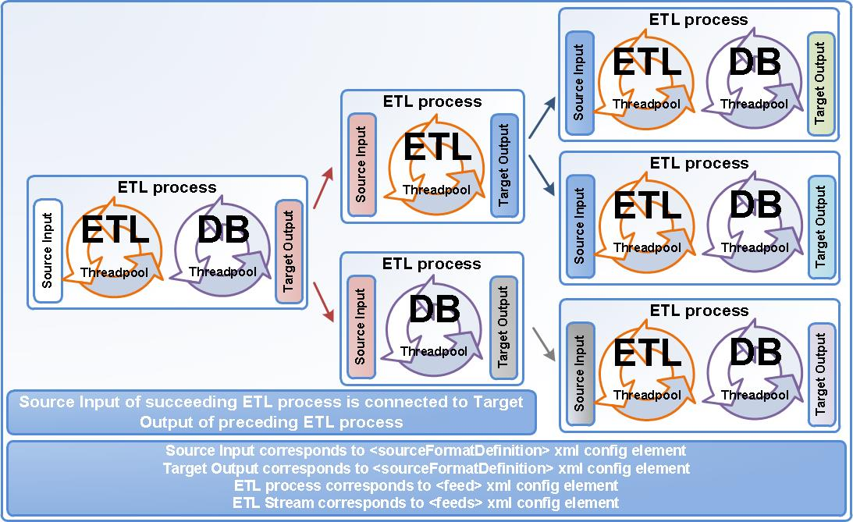

Figure: ETL Streams (Complex ETL process flows)

DB Threadpool is just a generic pool (OLAP integration example)

DB Threadpool is named as “DB” because most of deployments utilize it that way. However, that threadpool is generic and can be used for any purpose. For example, after we have loaded data via bulk loader into the database (as previously elaborated in “Configure target type for bulk loading”) we could simply add another command into target type of type of “shell” which will call OLAP load executable and pass it file name which need be uploaded to OLAP cube. For OLAP integration please see Tech FAQ page of StreamHorizon website.
User can define any number of “sql” or “shell” commands which will be executed in order as given in <bulkLoadInsert> element.
<target type="file">
<properties>
<property name="bulkOutputDirectory">/sh/data/bulk</property>
<property name="bulkLoadOutputExtension">data</property>
</properties>
<bulkLoadInsert>
<command type="sql">
CALL p_sh_external_table_load(${ffn[2]}, ${bulkProcessingThreadID},'${bulkFileName}', 0 )
</command>
<command type="shell">
/application/OLAP/loadIntoOlap.sh ${bulkFileName}
</command>
</bulkLoadInsert>
</target>

Source type definition
Source type definition determines type of a given feed (file, relational, message etc). StreamHorizon instance can have unlimited number of defined data feeds of which every feed definition contain source connectivity metadata
Supported Source type interfaces:
- File & Directory
- Hadoop
- Thrift based connectivity:
- Relational Databases
- Middleware Messaging
- Custom Java connectivity

File & Directory – processing input file feeds
StreamHorizon engine is configured to watch particular directory on disk (property: “directoryPath “) and process files found there. Different feeds can decide to watch for different files in the same directory this is achieved by setting file name regular expression in “fileNameMask” property. Different feeds <feed> can also look for files at their own directories.
Note: StreamHorizon has ability to decompress on the fly ‘gz’ and ‘zip’ formats. For example for ‘gz’ format property “fileNameMask” should have value “.*gz” while for ‘zip’ and ‘csv’ files values could be “.*zip” and “.*csv” respectively.
It is safe for multiple threads to watch the same source directory and all threads will evenly partition the work.
It is also possible to configure multiple StreamHorizon engine instances to watch the same source directory for same file mask(s) without collision, this requires explicit configuration (for more information see chapter “Clustering StreamHorizon”).
All ETL threads watch source directory, try to match them against their file name pattern. Files which pass criteria are processed in a round-robin fashion by first available thread in ETL threadpool.
Files are processed as configured in engine-config.xml file.
StreamHorizon engine will not start processing any file that was created or modified in the last 2 seconds. This is to ensure data consistency and avoid reading file someone is writing to. This delay is configurable and if your file system supports atomic file move operations you can decrease this value to zero (please see “General Properties” chapter).
StreamHorizon requires <source> element to be configured in configuration file for file source definition:
- directoryPath - Identifies source directory from which file feeds will be processed
- fileNameMask – Supplies filename masks for files whose processing is defined in enclosing <feed> definition. Multiple filemasks can be specified for a single enclosing <source> definition.
Example:
<source type="file">
<properties>
<property name="directoryPath">/app/data/source</property>
<property name="fileNameMask">.*csv</property>
</properties>
</source>

Note: If you wish to set file polling delay please refer to StreamHorizon property “file.polling.delay.millis”

Relational database source connectivity
StreamHorizon enables you to read data from relational database. All databases which support JDBC connectivity can be used.
In order to read from relational data source you need to define:
- JDBC connection string to source database
- A SQL statement which will retrieve data from the source system
- Schedule for a SQL statement execution.
Example:
<source type="jdbc">
<properties>
<! -- statement to use to select feed data. It must return data format as it is described in sourceFormatDefinition. This means that number of attributes (selected columns of SQL query) of "sqlStatement" and number of attributed defined in <sourceFormatDefinition><data><attributes> element must match.-->
<property name="sqlStatement">select column1, column2, column3, column4 from yourSourceTable order by id</property>
<! -- how often to run previous statement? any CRON expression supported by quartz is applicable. For more options see http://quartz-scheduler.org/ -->
<property name="schedule">0/2 * * * * ?</property>
<! -- JDBC connection string where source (feed) data can be found. Any JDBC data source is supported -->
<property name="jdbcUrl">jdbc:h2:mem:stream_horizon_test;DB_CLOSE_DELAY=-1</property>
</properties>
</source>

Thrift based connectivity
Thrift connectivity enables StreamHorizon to receive input data from any process that understands Thrift. This enables non-Java environments to communicate directly with StreamHorizon (for example C or C#).
When using RPC (Thrift) as a feed/data source you use the Thrift file available in streamhorizon-api-XYZ.jar and you should use it to generate your client code. When code is generated you can connect to Thrift server started by StreamHorizon engine (see configuration below). For more information visit thrift.apache.org
Example:
<source type="rpc">
<properties>
<!-- port on which Thrift server started as part of StreamHorizon engine should listen to -->
<property name="port">7890</property>
</properties>
</source>

Middleware messaging source connectivity
Please refer to “Middleware Connectivity & Setup” guide.

Hadoop source connectivity
Please refer to “Big Data Connectivity & Setup” guide.

Custom source connectivity
Please refer to “Custom Java Connectivity & Setup” guide.

Target type definition
Target type definition determines type of output of given ETL process (it is analogue to source type definition which defines input given to ETL process).
Supported Target type interfaces:
- File & Directory
- Hadoop
- Thrift based connectivity
- Relational Databases
- Middleware Messaging
- Custom Java connectivity based on StreamHorizon plugins

Supported target types (<target type="value">):
- Target type can have one of the following values: file/none/zip/gz/jdbc/pipe/rpc/hdfs
- When set to 'none' if you want to test performance of processing without actually writing bulk file to bulk output directory. 'none' value tests performance by eliminating write I/O
- When set to 'zip' output file will be zip compressed and will have .zip extension added
- When set to 'gz' output file will be gzip compressed and will have .gz extension added
- When set to 'jdbc' you must specify types for all attributes in <targetFormatDefinition> element and bulk records will be persisted using JDBC bulk interface
- It is also possible to provide your own target types by using StreamHorizon plugin system
Supported target type properties:
- bulkOutputDirectory - Property "bulkOutputDirectory" names directory where bulk files will be created. Bulk files usually have format of a fact table and are inserted into database by use of SQL*Loader, External Tables in case of Oracle or BULK INSERT command for MSSQL
- bulkLoadOutputExtension - Property "bulkLoadOutputExtension" defines the extension of bulk output file to be loaded by DB threads. DB threads will consider only files with given extension for loading into database. For example, if you expect 'zip' files to be loaded change this extension to zip (there is no need to add dot character for example '.zip'). If property is left as null or empty, extension will not be used as part of matching files in the bulk load folder
- bulkLoadFileDelimiter- Specifies delimiter to be used for attribute separation when creating bulk output file in CSV format. Whenever possible use single character delimiter
- outputFileNamePattern - property "outputFileNamePattern" enforces renaming bulk file after it has been generated by the engine. If you need this functionality:
  - Set this parameter if bulk output file is to be renamed after it is created (but before loaded by DB threads)
  - Any context variable can be used with ${ and } placeholder and engine will substitute it before renaming
  - Renamed file will be left in <bulkOutputDirectory> - you can not move file to other folder using this functionality
  - If no renaming is required leave this element empty or remove it
  - Arbitrary example of this pattern is myFile_${feedInputFileName}_${feedInputFileProcessingStartedTimestamp}.txt
- Custom parameters can be defined to suit your need when using Hadoop(HDFS) and/or Thrift implementations

Relational database target connectivity
In order to insert data into relational target (see chapter “Master Database”) target type need be setup as
- jdbc - if set to “jdbc” StreamHorizon ETL threads will insert data into target database
- pipe - if set to “pipe” StreamHorizon ETL threads will insert data into Oracle external tables via named pipes
- file - if set to “file” StreamHorizon ETL threads will create bulk files which will be loaded by External Tables or SQ*Loader (Oracle) or via BULK INSERT statement (MSSQL). Any database which supports bulk loading can implement this functionality via this setting.
JDBC target types insert statement (sql command):
<target type="jdbc">
<bulkLoadInsert>
<command type="sql">
insert into sales_fact (employee_id, customer_id, product_id, sales_channel_id, promotion_id, supplier_id, booking_date_id, sales_date_id, delivery_date_id, priceBeforeDiscount, priceAfterDiscount, saleCosts, sub, fileID) values (?,?,?,?,?,?, ${bookingDate} ,?,?,?,?,?,${feedProcessingThreadID},-1)
</command>
</bulkLoadInsert>
</target>
Usage of JDBC interface avoids generation of interim data files on disk and can help reducing IO. Processing logic and steps are exactly the same as if data is written to disk; the only difference is that loading happens in batches as data is being processed. Batch size can be configured (see chapter “General Properties”, property “jdbc.bulk.loading.batch.size”).
File target type insert statement (via stored procedure invocation):
<target type="file">
<properties>
<property name="bulkOutputDirectory">/sh/data/bulk</property>
<property name="bulkLoadOutputExtension">data</property>
</properties>
<bulkLoadInsert>
<command type="sql">
CALL p_sh_external_table_load(${ffn[2]}, ${bulkProcessingThreadID},'${bulkFileName}', 0 )
</command>
</bulkLoadInsert>
</target>
File target type insert statement (via OS script invocation):
<target type="file">
<properties>
<property name="bulkOutputDirectory">/sh/data/bulk</property>
<property name="bulkLoadOutputExtension">data</property>
</properties>
<bulkLoadInsert>
<command type="shell">D:\bauk\bin\bulk_loader.bat ${bulkFileName}</command> </bulkLoadInsert>
</target>

File target type insert statement via “pipe”:
Pipe deployment mode can be tuned to be the fastest mode of loading data using StreamHorizon into the database. This is because there are no intermediate persistence steps (no I/O) between StreamHorizon and the database in which external table load mode with Oracle is used. Before considering deployment in this mode make sure that your Unix/Linux system administrator and Infrastructure team can provide you adequate support in tuning size of Unix/Linux pipes (pipe buffer size). Default size for pipe buffers is usually inadequate (5KB) and thereby much smaller than required, much smaller than ideal size of the largest data file. This reduces out of the box throughput significantly for un-tuned systems to circa 400K records per second.
For Sample Demo pipe mode example please see “StreamHorizon Test Demo Deployment Guide”
<target type="pipe">
<bulkLoadInsert>
<command type="shell">
/sh/bin/sqlldr/pipe_invoke.sh ${feedProcessingThreadID} ${bulkNamedPipePath}
</command>
</bulkLoadInsert>
</target>
Note: Element <bulkLoadInsert> can have more than one command either of “sql” or “shell” type supplied.

File & directory target connectivity
Target type definition below defines directory where bulk files will be created by StreamHorizon engine, defines delimiter of the bulk files to be comma. It targets Oracle procedure to be used (note that context parameters like file name and DB thread ID are used as parameters passed to procedure):
<target type="file">
<properties>
<property name="bulkOutputDirectory">/tmp/stream_horizon/bulkOutput</property>
<property name="bulkLoadOutputExtension"></property>
<property name="bulkLoadFileDelimiter">,</property>
<property name="outputFileNamePattern"></property>
</properties>
<bulkLoadInsert>
<command type="sql">
CALL schema.procedureName(mod(${bulkProcessingThreadID},50),${bulkProcessingThreadID}, '${bulkFileName}' )
</command>
</bulkLoadInsert>
</target>
Note: Output files are created as temporary (with different extension) and atomically renamed only after all data has successfully been written. This prevents threads in DB pool (or any other process) to read half-written files.

Hadoop target connectivity

For HDFS (Hadoop) persistence custom Java implementation of persistence logic is required. Example for persistor is supplied in $ENGINE_HOME/plugins/HDFSOutputWriter.java. Note that target type need be set to “hdfs” (as defined by that specific plugin). It is, of course, possible to provide much better HDFS connector by using StreamHorizon plugins.
<target type="hdfs">
</target>

More information on how to write StreamHorizon plugins can be found here:
http://docs.oracle.com/javase/6/docs/api/java/util/ServiceLoader.html

Source format definition
Feed source format is specified in <data> element of the configuration file, child of < sourceFormatDefinition> element. All attributes are treated as strings (they can be converted into adequate data types if required). Input feed data attributes must be supplied in order as they appear from data source (file, database etc.).
Example:
Definition of data source format:
<data process="normal">
<!—This element relates only to file processing. Element isn’t mandatory and can be removed.
If data line is defined as line with special character please specify character here. It is assumed that character is delimited from data attributes by <delimiterString>. If data line has no special character erase this element. -->
<eachLineStartsWithCharacter>D</eachLineStartsWithCharacter>
<! -- This element relates only to ETL code customisation. Element isn’t mandatory and can be removed.
You can utilize custom data record parser class if you need to calculate/define new context parameter based on some of the header or Implicitly available engine attributes or execute any other custom logic. Note that this may significantly slow down the engine! Java extension will be invoked once for every data record (ever data row in every input feed file). Check DataMapper.java in $ENGINE_HOME/plugins/ folder for example -->
<feedDataProcessorClassName>DataMapper</feedDataProcessorClassName>
<!--define context names for all data attributes (in order as they appear in your data source)--> <attributes>
<attribute name="dataAttributeName_1" />
<attribute name="dataAttributeName_2" />
<attribute name="dataAttributeName_3" />
<attribute name="dataAttributeName_4" />
</attributes>
</data>
Note: To support “mainframe type” flat files StreamHorizon has ability to recognize data file by first character of the line having specific value. Only in such case element < eachLineStartsWithCharacter> should be used, else it should be omitted from all <header>, <data> and <footer> elements.

File header & footer
Note: For instructions how to inject custom Java class and override StreamHorizon default logic for header, footer and data (body) processing please refer to “Custom ETL Logic & Custom Context Parameters” subchapter.
If your data source is file for you may specify header & footer definition (assuming that file contains it). This is good practice if header attribute(s) hold same value for all records within the file; this is good way to reduce overall file size (and thereby overall I/O):
Example:
<header process="normal">
<! -- This element relates only to ETL code customisation. Element isn’t mandatory and can be removed.
You can utilize custom header record parser class if you need to calculate/define new context parameter based on some of the header or Implicitly available engine attributes or execute any other custom logic. Note that this may slow down the engine. Java extension will be invoked once for every header record (once per input feed file). Check CustomHeaderParser.java in $ENGINE_HOME/plugins/ folder for example -->
<headerParserClassName>CustomHeaderParser</headerParserClassName>
<! -- This element relates only to file processing. Element isn’t mandatory and can be removed.
If header line is defined as line with special character please specify character here. It is assumed that character is delimited from header attributes by <delimiterString>. if header line has no special character erase this element -->
<eachLineStartsWithCharacter>H</eachLineStartsWithCharacter>
<!--define context names for all data attributes (in order as they appear in your data source)--> <attributes>
<attribute name="headerAttributeName_1" />
<attribute name="headerAttributeName_2" />
<attribute name="headerAttributeName_3" />
</attributes>
</header>
If you use file feeds and wish to reconcile number of processed lines from a file with number of expected records in the file you may match rowcount in file footer with internal StreamHorizon rowcounter. Example below identifies footer record with start character ‘F’, and identifies that third attribute found within the footer (delimited by < delimiterString>) will be used as number (value) which will be matched by StreamHorizon in order to confirm that expected number of records in the file footer equals actual number of processed records in the file.
Example:

<footer process="strict">
<! -- This element relates only to file processing. Element isn’t mandatory and can be removed.
If footer line is defined as line with special character please specify character here. It is assumed that character is delimited from data attributes by <delimiterString>. If footer line has no special character erase this element -->
<eachLineStartsWithCharacter>F</eachLineStartsWithCharacter>
<! -- At what position will footer 'recordCount' attribute be found? if recordCount is third attribute in the footer set 3, if N'th attribute in the footer set property to N. Note that delimiter for footer is read from <delimiterString> element -->
<recordCountAttributePosition>3</recordCountAttributePosition>
</footer>
If desired, data records of the file can be marked with ‘D’ (or any other) character by configuring:
<data process="normal">
<!--if data line is defined as line with special character please specify character here. it is assumed that character is delimited from data attributes by <delimiterString>. if data line has no special character erase this element -->
<eachLineStartsWithCharacter>D</eachLineStartsWithCharacter>
</data>
Note: the <eachLineStartsWithCharacter> elements are optional for <data>, <header> and <footer> definitions.
Example:
This is example of arbitrary file format which has ‘H’ character as a indicator for header attribute, ‘F’ character for indicator for footer record. Note that third attribute of footer record has number 9 which signifies total number of records in the file. First and second footer attribute contain sum of all measures in given file. All footer attributes are optional and are given for illustration purposes only of what can be designed in terms of completion checking of your ETL processes. Data records of the file in example below are prefixed with character ‘D’.
H,20140107
D,277591820-4,Indigo,L,201.43,Roger Fox,445 Ohio Place,Congo,2,3
D,539292913-3,Fuscia,M,665.29,Arthur Young,55768 Granby Crossing,Libya,2,3
D,955961128-3,Red,2XL,119.15,Philip Stanley,748 Meadow Ridge Park,China,2,3
D,060207417-7,Khaki,L,238.38,Jacqueline Wallace,92318 Oneill Place,Slovakia,2,3
D,458165172-7,Blue,2XL,580.78,Virginia Mendoza,47981 Pond Park,Oman,2,3
D,323562307-8,Turquoise,3XL,234.76,Juan Oliver,208 Nobel Crossing,Canada,2,3
D,776221732-0,Crimson,XS,348.61,Lisa Walker,24 Eastlawn Drive,Netherlands,2,3
D,085677425-1,Indigo,2XL,706.07,Joyce Cox,0877 Doe Crossing Pass,Latvia,2,3
D,344969203-8,Goldenrod,XL,343.52,Theresa Greene,33 Menomonie Parkway,Rwanda,2,3
F,18,27,9

File processing modes
To accelerate file processing StreamHorizon engine has three file processing modes. File processing modes aim to reduce I/O (by reducing file size) and reduce CPU effort to parse given file, thereby, reducing ETL processing latency.
Full feed
Full feed is default file processing mode. Below is example of “full” feed file type containing 6 records. File delimiter is pipe “|”, file has 3 attributes in each record. Records 4 & 5 have NULL value for first attribute. Most of project use this design as standard file persistence model, this model brings no I/O or CPU savings as all attributes are persisted in every file record.
To process full feed type file, feed should be configured as: <feed name="MyDataFeed1" type="full">
a|b|c
a|b|d
b|b|e
|b|e
|b|e
a|a|a
Delta feed
Delta feed aims to save space and thereby reduce I/O when processing files. This is important if files come with partially sorted data. For example, in Finance, data generated by Quant Libraries comes partially sorted. This means that few adjacent records may have same attribute values (as if they have been sorted by those attributes).
For example, in a full feed above we can notice that first and second record have same values “a” and “b” for first two attributes of the file. We can also notice that third and fourth record have second attribute with same value “b”, fourth and fifth records have first attribute of same value (NULL which is presented as an empty string).
If your feeds contain “sorted data” the higher the sorting effect is, more savings can be gained by compacting the file size.
Full feed example given above can be processed as “delta” processing mode if you configure feed as: <feed name="MyDataFeed1" type="delta">
Note that if feed is configured as delta, file produced by your file generator should look in a following way (in order to be equivalent of the full feed example given above):
a|b|c
||d
b||e
~|b|e
||
a|a|a
It is obvious that second record stores “empty string” instead of values “a” and “b” as they are same as they were in the first record. StreamHorizon will interpret that second row actually looks like “a|b|c” if feed is configured as “delta” and record data in delta feed is “||d”.
Same applies for third row, second attribute of third row is “b”, as that attribute hasn’t changed since previous record (second record), delta feed should contain empty string instead of value “b”. StreamHorizon will ensure that it interprets this row as “b|b|e” as it will look like if it was supplied as full feed.
Note that for handling NULL values StreamHorizon must differentiate “null string” from NULL value. That is why for delta feeds user must declare characters which represent NULL value in feed. It is up to you to declare what set of characters should be treated as NULL value. Setting NULL value to character “~” can be achieved by following declaration in source definition:
<sourceFormatDefinition>
<!-- <nullString> is used only by 'type="delta"' (not 'type="full"') feed parsers -->
<nullString>~</nullString>
…
</sourceFormatDefinition>
Note that forth record in delta feed has NULL character supplied as “~” in delta feed file, also, as NULL value is repeated in the fifth record (is same as in previous record) it is stored as “empty string”.
Repetitive feed

Repetitive feed achieves compression and thereby achieves I/O performance improvements as well as high CPU effectiveness. If you have data which comes partially sorted and if you can determine which attributes are sorted by you may fully omit them in a following way:
Consider full feed of following file structure comprised of 11 attributes delimited with pipe “|”:
A|b|n|z|x|c|v|n|m|l|K
A|b|n|z|x|c|v|n|m|e|g
A|b|n|z|x|c|v|n|m|q|w
A|b|n|z|x|c|v|n|m|p|d
a|s|d|f|g|h|j|k|l|i|q
a|s|d|f|g|h|j|k|l|q|1
a|s|d|f|g|h|j|k|l|n|2
Note that second, third and fourth record have repetition (due to sort effect) of first nine attributes. First nine attributes for records 2, 3 and 4 are same as for the first record in the feed. As long as you omit persisting repeatable attribute values in lines 2, 3 and 4, StreamHorizon will “copy” their values from previous record, please see below:
A|b|n|z|x|c|v|n|m|l|K
|||||||||e|g
|||||||||q|w
|||||||||p|d
a|s|d|f|g|h|j|k|l|i|q
|||||||||q|1
|||||||||n|2
Record 5 is fully persisted as all attributes have different values compared to the previous record.
In order to configure repetitive feed please ensure that feed type is set to “full” and that number of repetitive attributes <repetitionCount> is supplied (positive integer value):
<feed name="MyDataFeed1" type="full">
…
<repetitionCount>9</repetitionCount>
…
</feed>
Note that first attribute of the file feed must be NOT NULL attribute, must not have null value. If first attribute was to have null value StreamHorizon engine could interpret that record as yet another repetition record, which may not be the case if line looks like “|x|t|e|q|f|j|u|o|p|g”. This record is obviously not repetition record, it contains all attributes populated, so, it is not repetition of its predecessor, only difference is that first attribute has null value, which to StreamHorizon makes it look like another repetitive record.

Extracting data from file Name
StreamHorizon has built in function to extract data attributes from the feed file name. For instructions on how to customise file name parsing please look at $ENGINE_HOME/plugins/CustomFeedFileNameProcessor.java example.
By default StreamHorizon comes with ability to process (parse) any feed file name and derive attributes from it if file name has underscore characters as data attributes. For example, file named sales_20140107_data_100.csv can be parsed without any customisation into variables with values “sales”, “20140107”, “data” and “100.csv”. Variables will be implicitly created as context variables and will be accessible in engine-config.xml and all Java customisations. These are variable & value pairs which will implicitly be present in a context:
ffn[0]= sales
ffn[1]= 20140107
ffn[2]= data
ffn[3]= 100.csv
Example of usage of data attribute derived from file name is shown below. Example is taken from $ENGINE_HOME/demo_sales/oracle/ext-table-deploy/engine-config*xml files. In this case ffn[1] returns date in format of YYYYMMDD extracted from file name (for example “sales_20140107_data_100.csv”). Value of 20140107 is passed via variable substitution (${ffn[1]} becomes 20140107) to p_sh_external_table_load Oracle stored procedure.
<bulkLoadInsert>
<command type="sql">
CALL p_sh_external_table_load(${ffn[1]}, ${bulkProcessingThreadID},'${bulkFileName}', 0 )
</command>
</bulkLoadInsert>
As already mentioned, it is possible to provide customized file name parsing plugin which can create its own context variables. If specified it will replace default file name parser. Look for < fileNameProcessorClassName> tag in examples.

Processing parallelism definition
StreamHorizon engine contains two processing threadpools, ETL and DB threadpool.
In case that you utilise JDBC inserts into the database (or use any source type like messaging, Hadoop, any other…) or simply persist flat files as output ETL threadpool need be configured.
In case when StreamHorizon works in bulk mode (loading bulk files into the database) DB threadpool need be defined. The DB threadpool can act as generic threadpool. For example if you use ETL threads to insert data into database via JDBC and use DB threadpool to execute <command type=”shell”> in order to trigger OLAP data upload or any other task. Note that for this purpose you can also use StreamHorizon events.
StreamHorizon threadpools can operate in following three modes of operation:
- ETL and DB processing
- ETL processing only
- DB processing only
To configure ETL threadpool to desired number of ETL threads you are required to set positive integer as a value of following element (child of <feed> element):
<etlProcessingThreadCount>40</etlProcessingThreadCount>
To configure DB threadpool to desired number of DB threads you are required to set positive integer as a value of following element (child of <feed> element):
<databaseProcessingThreadCount>40</databaseProcessingThreadCount>
If you configure both threadpools with positive integers as a value, both threadpools will work. If you wish not to use any of the threadpools set number of threads to zero.

Target format definition
Target format definition defines the output format (attributes) of your ETL process. Target type can be a feed file, bulk file, database table, message, Hadoop etc.
Attributes must be supplied in order in which they will appear in the output. Target output is generated by StreamHorizon context parameters in following ways:
1) If you wish to directly copy attribute from your source of data (for example source file or relational table) into the output you should use name of context attribute prefixed with ‘feed.’, this approach is most commonly used for measures in the source feed as they usually don’t get transformed by ETL. Please see example below
2) If you wish to use surrogate key (SK) of dimensional cache (which is most often the case) use name of dimension in question prefixed with 'dimension.' prefix. Please see example below.
3) Output attributes can be hardcoded values (constants) see example below with 'Y' and -1. If using hardcoded constant as string ensure you put appropriate database string delimiters (single quotes in this example)
4) Output attribute can be mapped to any global context (or custom context) attribute (just use context attribute name, no need for ${} characters.
<targetFormatDefinition>
<attributes>
<! -- order of attributes is important and determines definition of created bulk file (or generated JDBC statement) -->
<! -- dimension.XYZ means output calculated surrogate key (SK or ID) for dimension XYZ (based on dimension definition (please see below)) -->
<! -- datatypes supported are can be int/string/float -->
<attribute name="dimension.dimension1" type="int" /> <attribute name="dimension.dimension2" type="int" />
<! -- hardcoded/constant attributes. Will be copied directly to output. if string don't forget to supply string delimiters -->
<attribute type="int">-1</attribute>
<attribute type="string">Y</attribute>
<! -- Copy directly from input feed, as is.
this is an example of mapping value of measure directly from the feed -->
<attribute name="feed.dataAttributeName_7" type="float" />
<! -- attribute value will be mapped from context. It can be implicit context attribute or custom (created by one of the plugins) -->
<attribute name="customized.attribute.from.context" type="int" />
</attributes>
</targetFormatDefinition>

Custom ETL logic & custom context parameters
StreamHorizon engine by default performs full ETL processing which includes dimensional processing for all dimensional types (Type 1, Type 2, Insert Only and Custom). In order to offer developers full flexibility StreamHorizon supports injections of custom java code which give full power to the implementer over managing ETL logic implementation. ETL logic can be injected at any stage of ETL flow.
Java plugins are user provided Java classes implementing one of interfaces in StreamHorizon API. These plugins can be compiled, packaged as jar files and added to $ENGINE_HOME/ext-lib/ directory or source code (.java files) can be copied to $ENGINE_HOME/plugins/ directory where StreamHorizon engine will compile and use them.
Currently there are three types of plugins:
- User-defined file name parser – must implement com.threeglav.sh.bauk.feed.FeedFileNameProcessor interface
- User-defined

StreamHorizon enables developer to inject custom logic into any part of the ETL processing:
- Processing of every record of data source (every file record or any other source type record like database, message etc.) see example $ENGINE_HOME/ext-lib/CustomDataMapper.java
- Processing file name (see example $ENGINE_HOME/ext-lib/CustomFeedFileNameProcessor.java) – must implement com.threeglav.sh.bauk.feed.FeedDataLineProcessor interface - must implement com.threeglav.sh.bauk.feed.FeedFileNameProcessor interface
- Processing file Header (see example $ENGINE_HOME/ext-lib/CustomHeaderParser.java) – must implement com.threeglav.sh.bauk.header.HeaderParser interface
- Processing dimensions (custom dimensional logic) see $ENGINE_HOME/ext-lib/CustomDimensionDataProvider.java, detailed explanation of how this feature works is given below - must implement com.threeglav.sh.bauk.dimension.DimensionDataProvider interface
Examples of above customisations are available in $ENGINE_HOME/plugins/ directory, how to deploy them can be seen below or in $ENGINE_HOME/config/streamHorizonQuickXMLTutorial_engine_config.xml
Note: StreamHorizon engine will compile at startup all our java files, please make sure that character encoding of your java files is appropriate. If you deploy against many different servers you may instead java files provide pre compiled jar files placed in $ENGINE_HOME/ext-lib directory.
In the header element of source format definition:
Example below is triggered by StreamHorizon whenever new feed (new file for example) is processed by the ETL threads. Customisation takes effect when header line is passed. This is opportunity to set value of existing or new context variables.
<header process="normal">
<!--you can utilize custom header record parser class if you need to calculate/define new context parameter based on some of the header or Implicitly available engine attributes or execute any other custom logic. Note that this may slow down the engine. java extension will be invoked once for every header record (once per input feed file)-->
<!-- check CustomHeaderParser.java in $ENGINE_HOME/plugins/ folder for example -->
<headerParserClassName>CustomHeaderParser</headerParserClassName>
<!--if header line is defined as line with special character please specify character here. It is assumed that character is delimited from header attributes by <delimiterString>. if header line has no special character erase this element -->
</header>

In the data element of source format definition:
Example below is triggered by StreamHorizon whenever new record of a new feed (new file for example) is processed by any of the ETL threads. Customisation takes effect when header line is passed. This is opportunity to set value of existing or new context variables of StreamHorizon or override ETL behaviour of StreamHorizon with your custom ETL logic.
<data process="normal">
<!--you can utilize custom data record parser class if you need to calculate/define new context parameter based on some of the header or Implicitly available engine attributes or execute any other custom logic. Note that this may significantly slow down the engine! java extension will be invoked once for every data record (ever data row in every input feed file)-->
<!-- check CustomDataMapper.java in $ENGINE_HOME/plugins/ folder for example --> <feedDataProcessorClassName>CustomDataMapper</feedDataProcessorClassName>
<!--define context names for all data attributes (in order as they appear in your data source)-->
</data>

In the file name of the source format (note that customisation is child of <sourceFormatDefinition> element):
Example below is triggered by StreamHorizon whenever new feed (new file for example) is processed by any of the ETL threads. Customisation takes effect when header line is passed. This is opportunity to set value of existing or new context variables of StreamHorizon.
<feed>
<! -- Class name of custom implementation for feed file name processor. In case when some information should be extracted from file name of every input feed file it is possible to provide customized implementation to parse file name and provide new context attributes. Check CustomFeedFileNameProcessor.java in $ENGINE_HOME/plugins/ folder for example -->
<fileNameProcessorClassName>CustomFeedFileNameProcessor</fileNameProcessorClassName>
</feed>
Customizing dimensional logic:
Example below is triggered by StreamHorizon at instance startup. If particular dimension has complex mapping logic developer can implement a java class which will form collection (set of Natural Keys and Surrogate Keys) which will be used during ETL processing. Let’s assume that file feed contains attribute “American Dollar”, that database table has entry “USD” linked with surrogate key 1. In this case mapping logic need be executed to map value “American Dollar” to value “USD” for which surrogate key 1 is retrieved. Developer should ensure that custom mapping logic required returns “American Dollar” as natural key and 1 as surrogate key. This in effect abstracts mapping logic from StreamHorizon engine. If new natural key arrives in data feed, for example “British Pound” which hasn’t been returned by customised dimensional logic StreamHorizon will invoke supplied <sqlStatements> defined for dimension and insert record according to logic configured by developer.
<dimension name="dimension3" type="T1" exposeLastLineValueInContext="false" cachePerThreadEnabled="true">
<!-- class implementing com.threeglav.sh.bauk.dimension.DimensionDataProvider interface -->
<!-- returns additional mappings from natural to surrogate key for this dimension -->
<dimensionDataProviderClassName>com.threeglav.sh.bauk.integration.plugins.TestDimensionDataProvider</dimensionDataProviderClassName>
<localCacheMaxSize>...</localCacheMaxSize>
<mappedColumns>...</mappedColumns>
<sqlStatements>....</sqlStatements>
</dimension>

Processing events
Both ETL and DB threadpools generate events which are raised by every ETL and DB thread during processing of every data entity (file, message, and SQL query). Both threadpools have events which will be executed upon “success”, “failure” or “finally” (always executed, regardless of processing status (success or failure)).
Additional events are events raised “before” processing of data entity starts and event raised at startup of StreamHorizon instance. Another additional event <onStartupCommands> is raised on every startup of StreamHorizon instance, event logic should contain commands of SQL and shell type which will restore database, files, any other resource to coexistent state in case of power outage or any other unpredictable infrastructure (or programmatic) failure.
All events accept <command> elements, they enable you to invoke SQL or shell (sql statements and commands/executables) after ETL or DB thread has finished processing data entity (file, message etc.). This is very useful feature if you need to react with cleanup logic in case of failure, or, if you want to simply gather metrics when particular feed has been processed etc. All metrics (sh* views) which come with Sales Demo of StreamHorizon utilize event architecture to log performance metrics into the metric table sh_metric. All metric views are based on this single table which stores execution metadata of StreamHorizon engine.

 | ETL Thread events | DB Thread events | Startup event
Before Processing | <beforeFeedProcessing> | <beforeBulkLoadProcessing > | N/A
On Success | <afterFeedSuccess> | <afterBulkLoadSuccess> | N/A
On Failure | <afterFeedProcessingFailure> | <afterBulkLoadFailure> | N/A
Finally | <afterFeedProcessingCompletion> | <afterBulkLoadCompletion> | N/A
At StreamHorizon Instance Startup | N/A | N/A | <onStartupCommands>

To configure your ETL and DB threads to log processing metrics you could implement finally type events for both ETL and DB threads. Events will execute stored procedure calls against database and pass appropriate metadata (StreamHorizon context variables) as parameters. Following example is taken from Oracle external table load configuration of Sales Demo.

All commands for listed events are executed in order in which they are supplied in the configuration file.
All command statements of all events can utilize and will substitute values for any context variables supplied (if any). Please see examples below.

Using processing events for error handling
Errors in data processing can occur from many reasons. File format may be wrong, data quality may be poor. Events are raised when failures occur in ETL and/or in DB threads should be used to invoke SQL or OS scripts which can perform required error handling.
In case of errors files will be moved into configured error directory by StreamHorizon engine < errorDirecttory>

Using processing events in case of successful ETL completion
All listed events which are invoked upon successful completion of ETL and/or DB processing or, events which are invoked always (equivalent to finally{} clause in programming languages) can be utilized as SQL or OS script invocations or other dependent ETL steams for further data processing or for any other purpose.

Using processing events irrespective of completion status
Events like <afterBulkLoadCompletion> and < afterFeedProcessingCompletion> for DB and ETL thread respectively can be used to invoke OS script or SQL routines regardless of exist status of StreamHorizon process. Those events are equivalent to finally() block in Java and will be invoked after completion regardless of the status of the completed process.
Event examples:
<events>
<! -- All commands for given events are executed in order in which they are supplied in the configuration file.
All command statements of all events can utilize and will substitute values for any context attributes supplied (if any). Please see examples below. -->
<afterBulkLoadSuccess>
<! -- afterBulkLoadSuccess event is invoked after <bulkLoadInsert> statement is successfully executed. DB thread which does bulk loading executes supplied command(s) (if supplied) of this event. Commands are executed in given order and can receive/utilize any of engine context parameters. Any context attribute will be replaced with its value
Note that Oracle uses CALL while MSSQL uses EXEC keyword for execution. other vendors may have different keywords-->
<command type="shell">d:/first.bat ${someContextAttributePassedAsParameter}</command>
<command type="sql">CALL simpleproc1(${someContextAttribute1})</command>
<command type="sql">CALL simpleproc2('${firstContextAttr}',${secondContextAttr})</command>
<command type="shell">d:/second.bat</command>
</afterBulkLoadSuccess>
<afterFeedSuccess>
<!--afterFeedSuccess event is invoked upon successful execution of ETL thread fore ach data entity. Commands are executed in given order and can receive/utilize any of engine context parameters. Any context attribute will be replaced with its value
Note that Oracle uses CALL while MSSQL uses EXEC keyword for execution. other vendors may have different keywords-->
<command type="shell">d:/first.bat ${someContextAttributePassedAsParameter}</command>
<command type="sql">CALL simpleproc1(${someContextAttribute1})</command>
<command type="sql">CALL simpleproc2('${firstContextAttr}',${secondContextAttr})</command>
<command type="shell">d:/second.bat</command>
</afterFeedSuccess>
<afterBulkLoadFailure>
<! -- afterBulkLoadFailure event will be invoked only after loading of bulk data file by DB thread has failed (else it will be omitted). DB thread which does bulk loading executes given command(s) (if supplied). Commands are executed in given order and can receive/utilize any of engine context parameters.
By default feeds (files) are moved to error directory (<errorDirectory>) on processing failure.
Note that Oracle uses CALL while MSSQL uses EXEC keyword for execution. other vendors may have different keywords-->
<command type="shell">d:/first.bat</command>
<command type="sql">CALL simpleproc1(${someContextAttribute1})</command>
<command type="sql">CALL simpleproc2('${firstContextAttr}',${secondContextAttr})</command>
<command type="shell">d:/second.bat</command>
</afterBulkLoadFailure>
<afterBulkLoadCompletion>
<! -- afterBulkLoadCompletion event is executed by DB threads in order specified. Event is executed irrespective of success/failure of DB thread processing (think of event as finally{} block equivalent in Java) -->
<command type="sql">INSERT INTO BULK_LOAD_REC(cnt,filepath) VALUES(555, '${bulkFilePath}')</command>
<command type="shell">d:/first.bat</command>
</afterBulkLoadCompletion>
<beforeFeedProcessing>
<!-- beforeFeedProcessing event is executed by ETL threads (feed processing thread) before processing of feed starts -->
<command type="sql">update something in database</command>
<command type="shell">/opt/prepare.sh</command>
</beforeFeedProcessing>
<beforeBulkLoadProcessing>
<!-- beforeBulkLoadProcessingevent is executed by DB threads (db processing thread) before processing of data starts -->
<command type="sql">update something in database</command>
<command type="shell">/opt/prepare.sh</command>
</beforeBulkLoadProcessing>
<afterFeedProcessingFailure>
<!-- afterFeedProcessingFailure event is executed by ETL threads (feed processing threads) in the order specified in configuration file. Only if feed processing has failed this event will be triggered and supplied commands will be executed. Think of this event as catch{} block equivalent in Java
By default files are moved to error directory (<errorDirectory>) on processing failure -->
<command type="shell">d:/rollback.bat</command>
<command type="sql">UPDATE some table for rollback</command>
<command type="shell">d:/second_rollback.bat</command>
</afterFeedProcessingFailure>
<afterFeedProcessingCompletion>
<!-- afterFeedProcessingCompletion event is executed by ETL threads (feed processing threads) in specified order. Command(s) are is executed irrespective of success/failure of ETL thread processing (think of this as finally{} block equivalent in Java) -->
<command type="shell">d:/first.bat</command>
<command type="sql">CALL schema.function('${dataAttributeName_1}', trunc(to_date('${dataAttributeName_3}','DD/MM/YYYY')),
'hardcodedString',
${dimension1.sk}, /* example of use of surrogate key value from dimensional cache */
to_timestamp('${feedInputfileReceivedDateTime}', 'DD/MM/YYYY HH24:MI:SS.FF3'))
</command>
<command type="shell">d:/second.bat</command>
</afterFeedProcessingCompletion>
<onStartupCommands>
<!—onStartupCommands event is invoked during startup of StreamHorizon engine. This is event invoked only once which should execute all restore, backup, cleanup, integrity check or any other type of logic to ensure safe startup of StreamHorizon engine -->
<command type="shell">d:/scripts/onStartupRecoveryScript.sh</command>
<command type="shell">d:/startupDependencies.bat</command>
<command type="shell">d:/${someAttribute1}.bat</command>
<command type="sql">update fact_table set key=${someAttribute} where key=-100</command>
</onStartupCommands>
<events>

using processing events for gathering metrics & perfomrance statistics
StreamHorizon comes with metrics framework for performance throughput shipped within Sales Demo sample project. All metric views are supplied as database scripts.
Sales Demo is using events of StreamHorizon to insert record into metrics table sh_metrics after completion of ETL and/or DB thread execution. Metrics gathered in such a way reduce throughput between 10-17% depending on which mode StreamHorizon operates in (jdbc processing or database bulk loads). Few examples of using events to execute insert statements or stored procedures are shown below. Note that context parameters (predominantly global (implicit) context parameters defined and maintained by StreamHorizon engine are used to pass metadata parameters to stored procedures as parameters:
Oracle stored procedure invocations via StreamHorizon events:
<afterBulkLoadCompletion>
<command type="sql">
CALL log_sh_metrics_bulk('server_1',${engineInstanceIdentifier},${engineInstanceStartTimestamp},'afterBulkLoadCompletion','${bulkFileName}' ,${bulkFileProcessingStartedTimestamp},${bulkFileProcessingFinishedTimestamp}, '${bulkCompletionProcessingSuccessFailureFlag}', '${bulkCompletionProcessingErrorDescription}', ${bulkProcessingThreadID})
</command>
</afterBulkLoadCompletion>
<afterFeedProcessingCompletion>
<command type="sql">
CALL log_sh_metrics('server_1',${engineInstanceIdentifier},${engineInstanceStartTimestamp},'afterFeedProcessingCompletion',${feedInputFileReceivedTimestamp},${feedProcessingThreadID},'${feedInputFileName}',${feedInputFileProcessingStartedTimestamp},${feedInputFileProcessingFinishedTimestamp},${feedInputFileJdbcInsertStartedTimestamp},${feedInputFileJdbcInsertFinishedTimestamp},'${bulkFileAlreadySubmittedForLoading}',${bulkProcessingThreadID},'${bulkFilePath}','${bulkFileName}',${feedCompletionNumberOfTotalRowsInFeed},${bulkFileReceivedForProcessingTimestamp},${bulkFileProcessingStartedTimestamp},${bulkFileProcessingFinishedTimestamp},'${feedCompletionProcessingSuccessFailureFlag}','${feedCompletionProcessingErrorDescription}')
</command>
</afterFeedProcessingCompletion>
MSSQL stored procedure invocation via StreamHorizon events:
<afterBulkLoadCompletion>
<command type="sql">
EXEC log_sh_metrics_bulk 'server_1_mssql',${engineInstanceIdentifier},${engineInstanceStartTimestamp},'afterBulkLoadCompletion','${bulkFileName}' ,${bulkFileProcessingStartedTimestamp},${bulkFileProcessingFinishedTimestamp}, '${bulkCompletionProcessingSuccessFailureFlag}', '${bulkCompletionProcessingErrorDescription}',${bulkProcessingThreadID}, '${bulkFilePath}'
</command>
</afterBulkLoadCompletion>
<afterFeedProcessingCompletion>
<command type="sql">
EXEC log_sh_metrics 'server_1_mssql',${engineInstanceIdentifier},${engineInstanceStartTimestamp},'afterFeedProcessingCompletion',${feedInputFileReceivedTimestamp},${feedProcessingThreadID},'${feedInputFileName}',${feedInputFileProcessingStartedTimestamp},${feedInputFileProcessingFinishedTimestamp},${feedInputFileJdbcInsertStartedTimestamp},${feedInputFileJdbcInsertFinishedTimestamp},'${bulkFileAlreadySubmittedForLoading}',${bulkProcessingThreadID},'${bulkFilePath}','${bulkFileName}',${feedCompletionNumberOfTotalRowsInFeed},${bulkFileReceivedForProcessingTimestamp},${bulkFileProcessingStartedTimestamp},${bulkFileProcessingFinishedTimestamp},'${feedCompletionProcessingSuccessFailureFlag}','${feedCompletionProcessingErrorDescription}'
</command>
</afterFeedProcessingCompletion>

Logging
StreamHorizon log files are located in $ENGINE_HOME/log/ directory.
Log directory contains following three types of files:
- sh-engine-*.log - Main log file of StreamHorizon instance. This slog should be starting point of any investigation.
- etlEngine-*.log - Log of ETL threads of StreamHorizon engine
- dbLoadEngine-*.log – Log of DB threads of StreamHorizon engine
To customize any of logging behaviour please refer to $ENGINE_HOME/config/logback.xml configuration file

Archive & error directory
Every feed <feed> defined within StreamHorizon instance is required to be supplied with the following directories:
- <archiveDirectory> - This is directory where (for example) file feeds (input files) will be moved from source directory (property: “directoryPath”) after they have been processed by StreamHorizon engine.
- <errorDirecttory> - Error directory will contain feeds from source directory which have failed processing for any reason. For error & logging information please look at $ENGINE_HOME/log/engine*log files.

General properties <properties>
All stages of ETL processing of StreamHorizon can be configured & tuned by supplying configuration properties. It is possible to turn off certain features (like remote commands, local caches) or tune them to behave differently (for example use Hazelcast instead of Infinispan for caching, use different read buffer size etc), control your read & write I/O, enable partitioning, change JDBC commit size etc.
Configuration properties can be specified in engine-config.xml file and can also be overridden by providing Java system parameters with the same name. This is useful when multiple instances of StreamHorizon want to perform processing in the same way but only some parts need to be different. In this case engine configuration is template for processing, containing default tuning, and every instance overrides some of parameters by specifying them in startup scripts.
This section elaborates on <properties> element of engine-config.xml. All <properties> globally affect StreamHorizon instance and are valid for all feeds which are defined. The properties are very useful for both performance tuning and configuration of StreamHorizon.
In order to take effect after <property> values are changed StreamHorizon instance need be restarted.
Note that <property> element is a child of <properties> element of StreamHorizon configuration file and applies to all feeds defined for given StreamHorizon instance. If you require radically different properties setting you can always run multiple StreamHorizon instances on same (or separate) server.
"idempotent.feed.processing" default value: false
Should processed feed files be remembered or not (true/false). This setting essentially disables system to process input feed file with the same name twice if set to true.
In Production filenames are often guaranteed to be unique by data provider. This is important as it avoids case that files are sent twice to the StreamHorizon as that will effectively load data twice and cause ‘data duplication’. If enabled, this property will ensure that no file with same name is processed twice since instance of StreamHorizon is started.
In Development and Unit/System Test environments this setting is preferable to be set to false. This is due to fact that same data feeds are usually processed more than once by StreamHorizon. For example, if you wish to tune/test throughput of StreamHorizon ideal way to do it is to take representative data set and run same dataset while changing StreamHorizon parameters, ETL thread count and DB thread count.
"cache.provider" default value: ispn
StreamHorizon is shipped with two in memory grid engines (“global cache” providers in further writing) which are utilized for purpose of maintaining the cache of StreamHorizon engine. Choices are Hazelcast or Infinispan, values of parameters should be “hazelcast” or “ispn” depending on which engine you wish to utilize, default value is to use Infinispan. If global <cache.provider> doesn't contain lookup value database will be queried (insert will be tried, if fails, adequate key will be read) .
"dimension.local.cache.default.size" default value: 5000
Setting for default local cache size for dimensions. Setting can be overridden for every dimension (see <localCacheMaxSize>). Local cache is size of local collection each ETL thread has. Every ETL thread has one cache for every single dimension defined. Local cache speeds up dimension lookups.
"read.buffer.size.mb" default value: 10.0
Read buffer size (megabytes), parameter accepts decimal numbers. Adjust this value to be just over the size of your biggest source feed file. If your system is I/O bound try adjusting buffer size between 10% and 100% of source feed file in order to achieve best throughput.
"write.buffer.size.mb" default value: 10.0
Write buffer size (megabytes), parameter accepts decimal numbers. Adjust this value to be just over the size of your biggest bulk (our output) feed file. If your system is I/O bound try adjusting buffer size between 10% and 100% of source feed file in order to achieve best throughput.
NOTE: Both read.buffer.size.mb and write.buffer.size.mb need be tuned together. It is often the case that particular pattern need be imposed by this two settings which will efficiently utilize I/O bandwidth of the server.
NOTE: if you are processing in bulk mode (with DB thread count greater than zero) you may have two approaches:
- Have high ETL thread count which will interfere with DB load performance for short period of time, thereby finishing processing of incoming files quickly and leaving all bandwidth to DB loader threads
- Have balanced number of ETL threads and DB threads, such that bulk directory of StreamHorizon always have between 1x”DB threadpool size” and 2x “DB threadpool size” files available for DB threads to load. This effectively ensures that DB threads are always busy (always have next bulk files to process) and at the same time this ensures that ETL threads aren’t having larger footprint on I/O system than required. This tuning tip has assumption that database is always the bottleneck in processing which is valid for most of deployments.
"dimension.local.cache.disable" default value: false
Whether local cache for dimensions (local cache of ETL threads) should be disabled (true/false). Every ETL thread has local cache for every dimension which is defined. This setting is rarely changed to true, as in most of cases this will reduce throughput of the system.
"metrics.off" default value: false
Is exposing statistics feature off or on (true/false). No need to disable this parameter except in the case when hardware is CPU bound. Metrics are exposed to JMX and can be observed with JVisualVM, JMC or Hyperic.
"jdbc.client.info.program" default value:
This setting defines client connection name of the StreamHorizon. Setting embeds client information to simplify database connection audit and tuning. Set to empty if you wish not to use this feature (empty string is default value). You JDBC driver must support this feature (usually JDBC 4 drivers do support it). If your JDBC driver does not support this feature set this value to empty string in order to disable use of this feature in StreamHorizon.
"rename.archived.files" default value: false
Indicates whether files which are moved from source to archive folder should be renamed (renaming will result in appending date and time to the existing file name).
"dimension.precache.jdbc.fetch.size" default value: 10000
JDBC fetch size used when pre-caching dimension keys at startup of StreamHorizon instance. Must be a positive integer value. Dimension pre-caching is used by global cache “cache.provider” parameter at startup in order to reduce impact on database at runtime and avoid performance degradation. Pre-caching populates Infinispan or Hazelcast global cache with dimensional keys & attributes.
"dimension.precaching.disabled" default value: false
Whether pre-caching for all dimensions defined in engine-config.xml is disabled (for both global “cache.provider” (Infinispan/Hazelcast). This setting impacts ETL threads <etlProcessingThreadCount>.
Setting of this property to true would result in significant performance degradation.
"disable.dimension.combined.lookup" default value: true
Indicates if combined lookup feature for low cardinality dimensions should be disabled. Every dimension in engine-config.xml file can be marked as low-cardinality (<useInCombinedLookup> tag) and if this feature is not disabled then values for all those dimensions will be stored and looked-up together. If this configuration parameter is set to true (which is default) then marking dimensions to be used in combined lookup will be ignored. For low cardinality dimensions you might want to optimize caching of data by caching sets of data together and avoiding expensive parsing and lookups. This essentially means that instead of using one dimensional cache per single dimension in the database StreamHorizon may, under the hood, use single dimensional cache for more than one database table. This feature should be utilized for low cardinality dimensions only.
"scd.lock.striping.lock.count" default value: 50
Number of locks used when updating slowly-changing dimensions (T1 & T2). Must be positive integer. This parameter should not be modified unless advised by StreamHorizon support.
"output.processing.statistics" default value: false
Should processing statistics be written to log file and console as files are processed. This may be useful for metrics gathering from console in addition to provided sh_* views and tables which can be used for detailed performance monitoring.
"output.final.average.statistics" default value: false
Should average statistics be written to log file and console when engine is shut down. This statistics will list total number or files and records processed and average throughput.
NOTE: statistics will simply divide uptime of StreamHorizon instance with total number of records processed, thereby, if instance was idle during uptime metrics can be incorrect (very low). This setting should be used only in testing & development phase.
NOTE: If you are running StreamHorizon in bulk insert or external table mode (meaning in any other than JDBC or pipe mode) this setting will not list accurate end to end processing. It will rather give accurate throughput for ETL threads. The DB threads (loaders) may not have same throughput (assuming that DB loader threads are slower than ETL processing threads).
"bulk.output.file.null.value.string" default value:
This parameter defines what should actually be written in output (bulk) file when value of NULL need be persisted. By default this is empty string (no character will be written). This parameter has no default value specified.
"bulk.delete.files.after.load" default value: true
Specifies if bulk files will be deleted after they are loaded from bulk directory. If set to true, bulk files will be deleted from “bulkOutputDirectory”.
NOTE: During DB loader testing/tuning it may be desirable to leave rather than delete files after they are loaded into database. This is common practice when tuning DB threadpool load of bulk files into database. Note that by switching on ETL threadpool you may change your I/O utilisation patterns.
"bulk.file.record.submission.attempts" default value: false
Should engine record (internally) submission of every file it tries to bulk load? This setting is used for recovery purposes, in case when engine dies halfway through bulk-loading file it will know that file was submitted for loading beforehand (this info is persisted and it survives server crash (due to low of power for example) and/or forceful stop/restart (kill -9) of StreamHorizon instance).
"file.polling.delay.millis" default value: 1000
How often (in milliseconds) should StreamHorizon wait between two polling attempts for new files? This setting applies to both source and bulk directories (<source>and <target>), or in other words to all file feeds, bulk (or any other output files). This parameter will only be used when files are used as source and in cases when no new files can be found. In that case StreamHorizon will sleep for this period before trying to find new files.
"feed.file.acceptance.timeout.millis" default value: 2000
This property can be set to 0 if file system allows atomic renames/moves of files. Data corruption can occur in case someone is writing to files while engine is consuming them. This can be prevented by user (files can be renamed by file writer after writing is finished which makes file effectively ready for consumption by StreamHorizon engine).
Property specifies how old must be feed file <source type="file"> before it can be accepted for processing. When set to 0 StreamHorizon will process files immediately.
"bulk.file.acceptance.timeout.millis" default value: 2000
This property can be set to 0 if file system allows atomic renames/moves of files. Data corruption can occur in case someone is writing to files while engine is consuming them. This can be prevented by user (files can be renamed by file writer after writing is done which makes file effectively ready for consumption by StreamHorizon engine).
Property specifies how old must be bulk file <bulkOutputDirectory> before it can be accepted for processing. When set to 0 StreamHorizon will process files immediately.
"jdbc.bulk.loading.batch.size" default value: 10000
Batch size to be used when bulk loading data into table using JDBC. Whenever number of batched records reaches given number batched insert statement will be executed, committed and batching will start again (if more records are available in the feed).
"jdbc.threads.partition.count" default value: -1
Applicable for ETL threads <etlProcessingThreadCount> only when using JDBC mode of operation. Ensures that identifiers assigned to ETL threads are only in range [0 - (partition.count-1)] regardless how many ETL threads we have. If set to <=0 partitions will not be used.
NOTE: After you tune JDBC ETL threads and bulk batch size of JDBC inserts this is last tuning task remaining to improve performance. Aim is to set ETL thread count <etlProcessingThreadCount> to for example 40 while jdbc.threads.partition.count is set to 20. This will effectively force 40 ETL threads to queue with each other as StreamHorizon will allow only 20 threads at the time to insert into database in parallel. This (by design) creates queuing environment for ETL threads which has proven to be beneficial for performance (throughput gets increased up to 50%).
"bulk.load.threads.partition.count" default value: -1
Applicable to DB threads <databaseProcessingThreadCount> when performing bulk loading (not when ETL threads are doing inserts like: pipes and JDBC). Ensures that identifiers bulkProcessingPartitionedThreadID assigned to DB threads are only in range [0 – (partition.count-1)] regardless how many DB threads we have. If set to <=0 partitions will not be used
NOTE: Please see NOTE for property "jdbc.threads.partition.count" as same reasoning is valid for this setting as well.
"throughput.testing.mode" default value: false
This property eliminates read I/O bottleneck imposed by your I/O system while testing. When set to true, ETL threads <etlProcessingThreadCount> will each cache one random file and process it not by reading it from disk but by reading it from repeatedly (while test lasts - until StreamHorizon process is alive) from internal JVM buffer. This will give idea of throughput without read I/O bottleneck. It is advisable that source directory contains more files than number of ETL threads <etlProcessingThreadCount > while performing this test. If you have 20 ETL threads and only 7 files in source directory StreamHorizon will run with throughput of effectively 7 ETL threads (rather than with 20).
"remoting.server.port" default value: 21000
Specifies port to be used by http server for remote commands. If set to zero http server will not be started.

Flushing caches via HTTP
If some other process, rather than StreamHorizon updates database dimensional tables that implies that global cache (Infinispan/Hazelcast) and local caches of StreamHorizon are out of date (they may contain stale values). You could make StreamHorizon engine flush all dimensional caches if you execute the following statement: http://localhost:21000/flushDimensionCache/?dimension=dimension1
If you have stored procedures or any other code altering/writing into dimensions, for example, you may have routine which updates list of products in product dimension (routine not running as part of StreamHorizon). In that case StreamHorizon will not be aware that some of dimensional records may be deleted, inserted or updated. In order to force refresh internal (global and local) StreamHorizon caches all you need to do is after your non-StreamHorizon ETL routine changes dimension(s) you need to flush via HTTP request all dimensions which may have been altered.
StreamHorizon will ensure that changes in dimensional caches will not take place in the middle of the processing of a single file (or any other data entity). After it receives dimension cache flush request StreamHorizon will finish processing file (if it is in the middle of the processing) and apply cache flush before it consumes next file from source directory.
Command syntax:
http://<serverName>:<remoting.server.port>/flushDimensionCache/?dimension=<dimensionNameAsDefinedInConfig>
When above command is executed engine will go through a set of steps:
- Wait for all threads to finish their current work
- Pause all threads so that they do not accept new work
- Flush data cached for specified dimension
- Notify all threads that they can continue processing data
Please note that after flushing dimension cache there is expected slow-down in execution for a few seconds because cache will be populated as needed and this might require execution of database queries.

Monitoring via jvm
StreamHorizon exposes internal processing metrics via JMX.
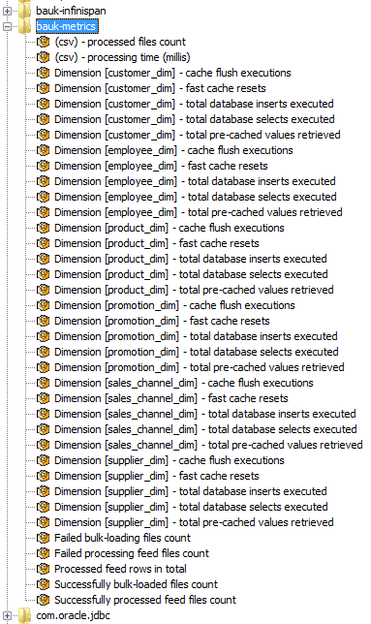
It is also possible to use extension points to collect and calculate metrics about performance of engine. See the sales demo provided with installation for more details (sh_metrics table).

Emailing & Alerting
Following parameters are used to setup StreamHorizon emailing functionality. Note that emails will be sent to all listed recipients whenever ERROR event occurs in StreamHorizon engine. WARN or other type of events which may be logged in log files aren’t available via email functionality.
"email.server.host" default value: emailServerHostName
NOTE: Above default value must be replaced with your email server hostname if you wish to exploit feature
"email.server.username" default value:
NOTE: Above default value must be set; it is not supplied by default
"email.server.password" default value:
NOTE: Above default value must be set; it is not supplied by default
"email.server.port" default value: 25
NOTE: Above default value may need to be changed depending on settings of your email server
"processing.error.email.recipients" default value: a@b.com,c@d.com
Above property supplies comma delimited list of email addresses to which email alerts will be sent
NOTE: Above default value must be replaced with meaningful email addresses if you wish to exploit feature

Startup and recovery
StreamHorizon provides events which are invoked on startup of the StreamHorizon instance. These events can be used for:
- Checks or startup and recovery purposes (in case of loss of power, or any other unexpected hardware of infrastructure failure)
- General housekeeping
- As triggers for any subsequent ETL processing like OLAP data uploads, pushing data to other systems etc.
On startup following command types are supported:
- sql – any SQL command, procedure or function can be invoked
- shell – any OS executable/script can be invoked
Note:
- All commands are executed in order as they appear in configuration file.
- All context variables will be substituted (if supplied) prior to execution of given commands/statements. For more information refer to “Context variables” chapter.
- Definition of <onStartupCommands> is not mandatory (see “Events” chapter for more details)
- Definition of <onStartupCommands> should be specified (if required) for every source feed <feed>
Example:
<onStartupCommands>
<command type="shell">d:/scripts/onStartupRecoveryScript.sh</command>
<command type="shell">d:/startupDependencies.bat</command>
<command type="shell">d:/${someAttribute1}.bat</command>
<command type="sql">update fact_table set key=${someAttribute} where key=-100</command>
</onStartupCommands>

Clustering StreamHorizon (Local cluster deployment & OTHER)
It is possible to run multiple StreamHorizon engine instances (in multiple JVM’s) and let them partition processing and data loading. It is not a requirement to run all StreamHorizon instances on the same physical machine, you can run StreamHorizon instances on different blades and still have clustering working properly but minimum requirement is to have networking (TCP or UDP) correctly setup between all clustered instances.
There are multiple ways to achieve clustering of StreamHorizon engine instances.

StreamHorizon instances are independent
This is simplest deployment where multiple instances are started and all of them point to different source directories and process files independently. There is no need for any partitioning or interaction between StreamHorizon instances in this case.

StreamHorizon instances share same source directory
If it is required for multiple StreamHorizon instances to watch same source directory then it is very important to partition work between engine instances correctly. Otherwise different instances can start processing same files.
In order to do this it is important to assign unique integer identifier to every StreamHorizon engine instance and also set a total number of instances running. This is all achieved by using customized startup script and is shown in $ENGINE_HOME/demo_sales/local_cluster_example/ (please see snippets below).
It is recommended to contact StreamHorizon support for more details.

StreamHorizon instances share dimension caches
This option can be combined with previous option (sharing same source directory).
In order to minimize access to database it can be useful to share cached data between multiple StreamHorizon engine instances. This is achieved by configuring caching to be shared (replicated or distributed). Please contact StreamHorizon support for more details.
Example:
Examples used are available in $ENGINE_HOME/demo_sales/local_cluster_example/ directory. Note that every *.bat file (same applies for equivalent Unix shell files) requires re-defines (by setting) StreamHorizon Global Variables like etlProcessingThreadCount and databaseProcessingThreadCount.
In order to ensure that instances are “aware of each other” and that they don’t consume each others resources (files) it is necessary to set “engineInstanceId” and “totalInstancesCount” parameters.
Example below represents configuration for cluster of four instances, thereby parameter “totalInstancesCount” is set to 4 in all *.bat files, while parameter “engineInstanceId” has unique value of 0,1,2,3 across all *.bat files.
Setting of other attributes (presented in listings below) like etlProcessingThreadCount, databaseProcessingThreadCount, readBufferSizeMb etc. are specific to your deployment and are not mandatory for StreamHorizon cluster deployment mode to function.
File Start_local_cluster.bat shown below executes startup of all cluster instances.
Local_cluster_mode0.bat content:
rem copy this file in case you want to run multiple instances of engine processing files from same source folder (<sourceDirectory> tag in engine-config.xml file)
rem ensure you assign unique integer identifier to every instance
rem must be non-negative integer (0-number_of_instances-1)
set "engineInstanceId=0"
rem should be set only when multiple instances are processing files from the same feed source folder (<sourceDirectory> tag in engine-config.xml file)
set "totalInstancesCount=4"
set "heapSizeGb=8"
rem FOLLOWING VALUES WILL OVERRIDE VALUES IN engine-config.xml
set "etlProcessingThreadCount=2"
set "databaseProcessingThreadCount=0"
set "readBufferSizeMb=20"
set "writeBufferSizeMb=20"
set "jdbcLoadBatchSize=1000"
start.bat %engineInstanceId% %heapSizeGb% "-DetlProcessingThreadCount=%etlProcessingThreadCount% -DdatabaseProcessingThreadCount=%databaseProcessingThreadCount% -Dread.buffer.size.mb=%readBufferSizeMb% -Dwrite.buffer.size.mb=%writeBufferSizeMb% -Djdbc.bulk.loading.batch.size=%jdbcLoadBatchSize% -Dmulti.instance.total.partition.count=%totalInstancesCount%"
Local_cluster_mode1.bat content:
rem copy this file in case you want to run multiple instances of engine processing files from same source folder (<sourceDirectory> tag in engine-config.xml file)
rem ensure you assign unique integer identifier to every instance

rem must be non-negative integer (0-number_of_instances-1)
set "engineInstanceId=1"
rem should be set only when multiple instances are processing files from the same feed source folder (<sourceDirectory> tag in engine-config.xml file)
set "totalInstancesCount=4"
set "heapSizeGb=8"
rem FOLLOWING VALUES WILL OVERRIDE VALUES IN engine-config.xml
set "etlProcessingThreadCount=2"
set "databaseProcessingThreadCount=0"
set "readBufferSizeMb=20"
set "writeBufferSizeMb=20"
set "jdbcLoadBatchSize=1000"
start.bat %engineInstanceId% %heapSizeGb% "-DetlProcessingThreadCount=%etlProcessingThreadCount% -DdatabaseProcessingThreadCount=%databaseProcessingThreadCount% -Dread.buffer.size.mb=%readBufferSizeMb% -Dwrite.buffer.size.mb=%writeBufferSizeMb% -Djdbc.bulk.loading.batch.size=%jdbcLoadBatchSize% -Dmulti.instance.total.partition.count=%totalInstancesCount%"
Local_cluster_mode2.bat content:
rem copy this file in case you want to run multiple instances of engine processing files from same source folder (<sourceDirectory> tag in engine-config.xml file)
rem ensure you assign unique integer identifier to every instance
rem must be non-negative integer (0-number_of_instances-1)
set "engineInstanceId=2"
rem should be set only when multiple instances are processing files from the same feed source folder (<sourceDirectory> tag in engine-config.xml file)
set "totalInstancesCount=4"
set "heapSizeGb=8"
rem FOLLOWING VALUES WILL OVERRIDE VALUES IN engine-config.xml
set "etlProcessingThreadCount=2"
set "databaseProcessingThreadCount=0"
set "readBufferSizeMb=20"
set "writeBufferSizeMb=20"
set "jdbcLoadBatchSize=1000"
start.bat %engineInstanceId% %heapSizeGb% "-DetlProcessingThreadCount=%etlProcessingThreadCount% -DdatabaseProcessingThreadCount=%databaseProcessingThreadCount% -Dread.buffer.size.mb=%readBufferSizeMb% -Dwrite.buffer.size.mb=%writeBufferSizeMb% -Djdbc.bulk.loading.batch.size=%jdbcLoadBatchSize% -Dmulti.instance.total.partition.count=%totalInstancesCount%"
Local_cluster_mode3.bat content:
rem copy this file in case you want to run multiple instances of engine processing files from same source folder (<sourceDirectory> tag in engine-config.xml file)
rem ensure you assign unique integer identifier to every instance
rem must be non-negative integer (0-number_of_instances-1)
set "engineInstanceId=3"
rem should be set only when multiple instances are processing files from the same feed source folder (<sourceDirectory> tag in engine-config.xml file)
set "totalInstancesCount=4"
set "heapSizeGb=8"
rem FOLLOWING VALUES WILL OVERRIDE VALUES IN engine-config.xml
set "etlProcessingThreadCount=2"
set "databaseProcessingThreadCount=0"
set "readBufferSizeMb=20"
set "writeBufferSizeMb=20"
set "jdbcLoadBatchSize=1000"
start.bat %engineInstanceId% %heapSizeGb% "-DetlProcessingThreadCount=%etlProcessingThreadCount% -DdatabaseProcessingThreadCount=%databaseProcessingThreadCount% -Dread.buffer.size.mb=%readBufferSizeMb% -Dwrite.buffer.size.mb=%writeBufferSizeMb% -Djdbc.bulk.loading.batch.size=%jdbcLoadBatchSize% -Dmulti.instance.total.partition.count=%totalInstancesCount%"
Start_local_cluster.bat content (used to start all clustered StreamHorizon instances):

START local_cluster_mode_0.bat
START local_cluster_mode_1.bat
START local_cluster_mode_2.bat
START local_cluster_mode_3.bat

Deployment strategies

Deployment flavours of ETL & DB threadpools
In most of deployments StreamHorizon will run with both, ETL and DB threadpool. Here are few typical use deployment architectures of the platform:
- If you insert data via JDBC, named pipes or any other (excluding bulk load mode) mode you shall configure only ETL threadpool.
- Exception to rule above is when you wish to load data via JDBC into database and use DB threadpool as “Generic threadpool”. In such case you may wish to configure both, ETL and DB threadpools. DB threadpool can trigger OLAP data upload, load of data to another database, file or Hadoop, or do what ever your requirements are. Bear in mind that instead of using DB Threadpool as “Generic threadpool” you may wish to use events raised by ETL threadpool as they can achieve same goal with smaller number of overall threads running on your server. Of course, ETL throughput will be reduced in this case as all event calls are synchronized calls.
- For DB threadpool to function as Generic Threadpool all you need to do is to omit <bulkLoadInsert> element.
- If you wish to upload data into OLAP cube or Hadoop or perform any other task after data has been loaded via bulk mode into the database you can simply supply multiple commands to <bulkLoadInsert> element. They will all be executed in order in which they are provided. You may wish to generate aggregation for data which has just been loaded into the database. Slightly better approach for this is that you write single procedure which will do both, inset of transactional and aggregation and insert of aggregated data. This way data is more likely to still be in the cache when you execute your aggregation routine (and you will be making tow network roundtrips less). Please see example (engine-config.xml) of StreamHorizon demo for oracle external table load.
- If you wish to load data from for example, source files via bulk load you need to configure both ETL and DB threadpools
- If you wish to load data in any other mode like Hadoop, via Custom Java target extensions, Thrift, create files on HDFS or local filesystems you are most likely to need to configure only ETL pool unless you wish to use DB Threadpool as Generic Threadpool (note that ETL Thread events can be used to achieve similar goals as stated above)

Deployment flavours of ETL & DB threadpools
Image below illustrates some of deployment modes of StreamHorizon:
- ETL mode (single instance) – Mode used to run StreamHorizon as file to file, file to DB (jdbc), file to DB (pipe), thrift to jdbc, thrift to file, DB to DB (jdbc), DB to file, DB to thrift…or any other possible connector variation which requires only single ETL threadpool to run
- DB mode (single instance) – utilized when DB threadpool is required to bulk load data into the target database. DB threadpool (without ETL threadpool) is mostly used in “Dedicated DB Loader Instance” scenario, please see second image below. If you wish to reduce I/O at your server you may decide that feed files are processed by StreamHorizon engines at workstations or any other (non DB server). This will push read of feed files away from DB server thereby enabling DB server to have more I/O bandwidth. In this deployment scenario StreamHorizon instances running in exclusive ETL mode are processing feed files and creating bulk files in file directory of your choice. DB mode “Dedicated DB Loader Instance” is simply just loading bulk files into the database. This architecture can provide gain in overall throughput as I/O of reading feed files is pushed away from DB server. Alternative is that you may run “ETL & DB mode (single instance)”, please see pros & cons of running of this mode below.
- Generic threadpool – “DB Threadpool” in all deployment architectures can be considered to be “Generic Threadpool”. You can simply utilize DB threadpool to for example load data into the OLAP engine rather than database, or load data in any other way into any type of target. That is why DB threadpool should be thought of as Generic threadpool. Same effect can be achieved by utilizing StreamHorizon events which are available for both ETL and DB threadpools. For more information please read “Events” chapter of this guide.
- ETL & DB mode (single instance) – This mode is most often utilised if you use Bulk Insert method to insert data into your database. StreamHorizon demo comes with Oracle and MSSQL examples of this mode of operation. ETL threadpool read & process file feeds (or any other data source) and create bulk files. Bulk files are picked up by DB Threads which insert it into the target database. It is critical that this deployment has right balance of production of bulk files (right number of ETL threads) and consumption of bulk files (bulk files are consumed by DB threads, they are inserted into database) in order to achieve optimal throughput of the StreamHorizon instance.
- ETL mode (local cluster) – Architecture of running multiple StreamHorizon instances on a single server. This architecture may be consider if for any reason you need to run multiple StreamHorizon instances on a single server. For example, if you have need to customize StreamHorizon processing to interrogate any data source which has limited bandwidth (for example your custom dimension logic interrogates your SOAP service), you may deploy multiple SOAP services and each StreamHorizon instance from local cluster could interrogate dedicated SOAP service. This is one way in which you can increase overall data processing throughput.
- DB mode (local cluster) – same reasoning applies as for ETL mode (local cluster)
- ETL & DB (local clusters) – same reasoning applies as for ETL mode (local cluster)
- ETL (local cluster) & DB (single instance) – should be used to achieve right balance between overall throughput of all ETL instances and DB instance in terms of optimizing data throughput.
- ETL (single instance) & DB (local cluster) - should be used to achieve right balance between overall throughput of all ETL instance and DB instances in terms of optimizing data throughput.
- ETL & DB local cluster is mode which is mix of both “ETL & DB mode (single instance)” and “ETL & DB (local clusters)” deployment modes; as such it brings benefits and flexibility of both of this modes in terms of optimization of data throughput.
Note: Most commonly used types of deployments are “ETL mode (single instance)” and “ETL & DB mode (single instance)”. StreamHorizon demo runs JDBC inserts in ETL mode (as DB threadpool count is set to zero), while demos for Bulk Inserts are using ETL & DB mode.
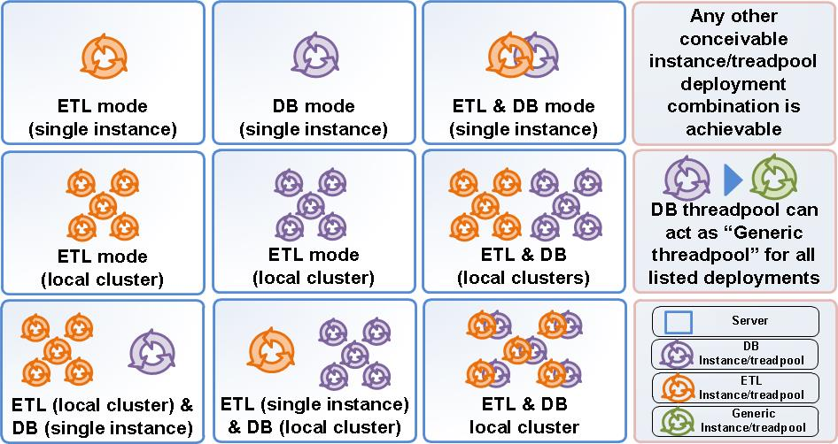
Figure: Architectural Deployments

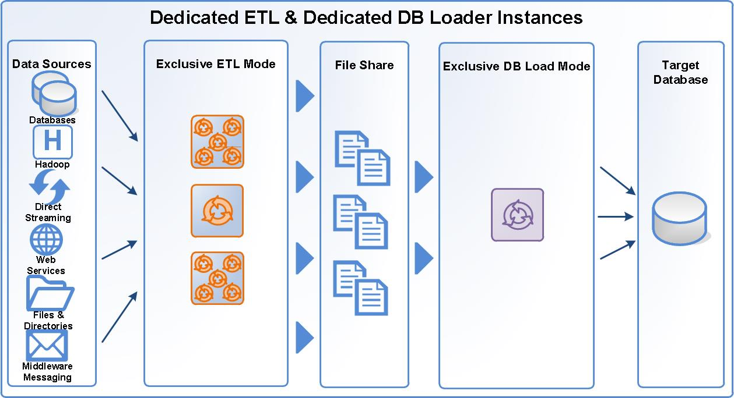
Figure: Dedicated ETL & Dedicated DB Loader Instances*
*-Note that figure above does not imply “Exclusive DB Load Mode” Stream Horizon instance should not reside on Target Database server. If your DB server is CPU over utilised you may consider running StreamHorizon in Exclusive DB Loader mode on different server. StreamHorizon however has very small CPU footprint when running in Exclusive DB Loader mode.

ETL GRID deployments
StreamHorizon can be executed on multiple servers of diverse hardware and OS specifications. StreamHorizon is tested on EC2 and other major compute clouds. Idea behind ETL Grid is to deliver robust horizontally (and vertically) scaling architecture which can process much more than million records of data per second which is throughput achievable with a single StreamHorizon instance.

Image below we see examples of single StreamHorizon instance running on the single box as well as multiple (local cluster) deployment of StreamHorizon on a single box. Drawing at the bottom depicts multiple boxes which have their own custom (tailored to fit your needs) mixtures of variations of StreamHorizon deployed across multiple servers. Such cluster of servers we refer to as ETL Grid.
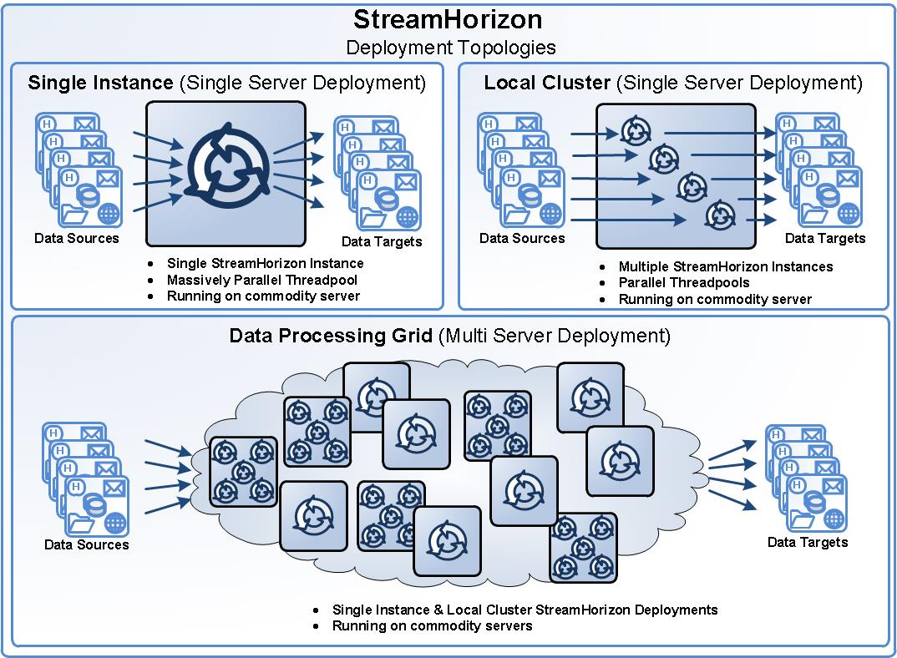
Figure: Single Server and Grid deployment topologies

Compute Grids are long present in industries which execute large number of complex computation. For example, in Finance (Investment Banking Industry) product valuation and pricing is done on large CPU Grids (Compute Grids). Aim is to break long running calculation into small fragments which are shipped as base unit of calculation to random node in Compute Grid. All results are gathered and collated after calculation is done.
ETL Grid is StreamHorizon response to concept of Compute Grid which enables end users to build ETL Grid (Data Processing Farm) of unlimited data processing capacity.

ETL GRID cohabited with compute grid
Apart from enabling you to design/deliver your ETL Grid, StreamHorizon architecture is compliant with current Compute Grid architecture on conventional and Big Data (Hadoop) ecosystems.
Below are few flavours (of many) achievable deployments:
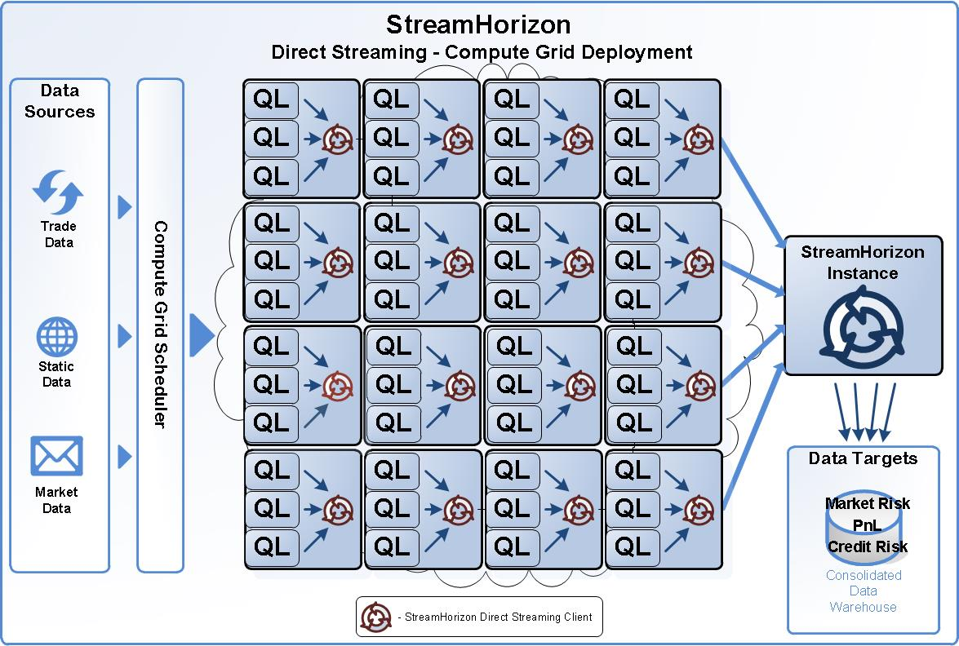
Figure: Stream Horizon instances deployed across nodes of Compute Grid process data and persist files to dedicated StreamHorizon DB instance which loads data into the Data Warehouse.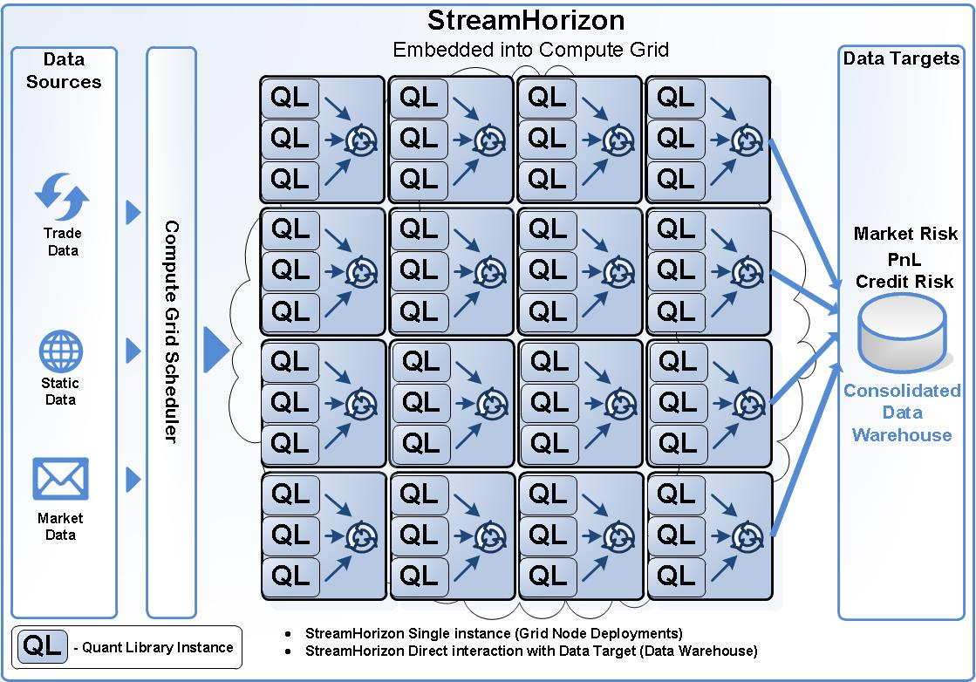
Figure: Stream Horizon instances deployed across nodes of Compute Grid process persist data directly into the Data Warehouse.
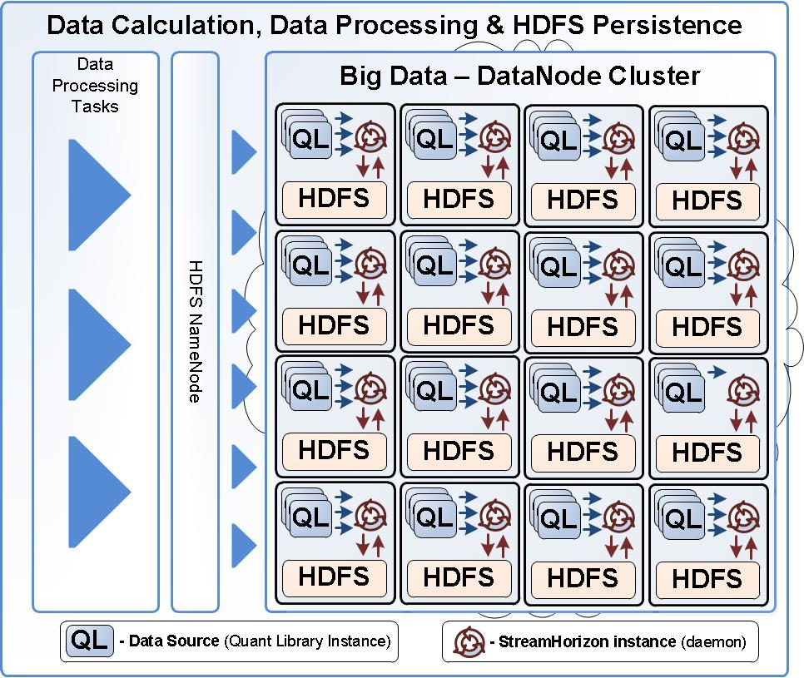
Figure: Stream Horizon instances deployed across nodes of Hadoop Ecosystem process data and persist files to HDFS file system (or any other Hadoop target of your choice)

Note that above sample architectural deployments present only few possibilities of what is achievable with StreamHorizon. Being designed as a lightweight Java process, StreamHorizon can easily fit into any enterprise architecture in a ways most optimal way to address your data processing requirements.

Performance tuning
Performance tuning is presented as a set of topics which you may consider during performance tuning & deployment of StreamHorizon.

Deployment types
In order to gain insight which deployment type of StreamHorizon suits best your needs please read chapter “Deployment Strategies” of this document. This chapter will give you good insight how to deploy StreamHorizon to maximise data throughput given your existing I/O and CPU hardware constraints and achieve minimal latency of your system.

What is desired threadpool size?
Rough estimate is that (assuming that your server is not under heavy load) you should set threadpool size to number of cores of your server. So, for 24 core server for JDBC following settings should be used:
- <etlProcessingThreadCount>24</etlProcessingThreadCount>
- <databaseProcessingThreadCount>0</databaseProcessingThreadCount>
For BULK LOAD deployment following should be used:
- <etlProcessingThreadCount>24</etlProcessingThreadCount>
- <databaseProcessingThreadCount>24</databaseProcessingThreadCount>
Please modify your threadpool sizes and save changes in engine-config.xml file and restart StreamHorizon.
Some processors (new generations) perform better than processor of old servers, in which case one can utilise two times number of free CPU cores as starting point for ETL threadpool size. Matching number of free CPU cores is good starting point, however, establishing right size of threadpool for given server must be done via multiple trials. You should use StreamHorizon Sales Demo metrics framework to measure performance of your StreamHorizon instance. More information on how to derive metrics StreamHorizon benchmarking can be obtained below, see “Other Metrics & Views” subchapter.
Some hardware setups which have fast CPU and relatively slow I/O perform best with setting where ETL threadpool is approximately two times smaller than DB threadpool:
- <etlProcessingThreadCount>24</etlProcessingThreadCount>
- <databaseProcessingThreadCount>50</databaseProcessingThreadCount>
This is why it is important to experiment with different threadpool sizes for every deployment. Such approach allows you to strike right balance between your CPU and I/O resources.

Right balance between ETL & DB threadpools
When running StreamHorizon in “ETL & DB mode (single instance)” or any other mode which involves both (ETL & DB threadpools) it is important to get data production (production of bulk files) in line with data consumption (inserting of data files into the database). ETL threadpool size will determine production of bulk files while DB threadpool size will determine pace of loading of data into the database.
It is advisable to run StreamHorizon in both modes (ETL only) and (DB only) and see what is highest performance of each threadpool when operating on their own. When you determine highest throughput for ETL threadpool, lets say highest throughput (number or records processed per second) is achieved with 24 threads in ETL threadpool, and lets assume that maximum DB throughput is achieved with 50 threads in DB threadpool you may switch them both on with same settings 24 & 50. You will most likely notice that at that point overall throughput will be lower. This is because both threadpools are competing for I/O (or sometimes even CPU) resources.
Note: When running StreamHorizon with only one (ETL or in DB) threadpool active (number of threads > 0) finding maximum throughput is all that need be done for tuning.
Tuning ETL & DB threadpools (when both are active) translates into finding right balance between size of ETL and DB treadpool. We have given example of 24/50 as example earlier when running each threadpool on their own. You may find that overall throughput on your hardware may be optimal with setup 20/50 or even 36/40 respectively for ETL/DB threadpool size. For example, if ETL threads consume more I/O and CPU resources than DB threads maximum throughput will most likely be achieved with higher ratio of ETL threads (compared to DB threads) 36/40 for example. If DB threads (database inserts) are consuming more resources, highest throughput will most likely be achieved with ETL/DB thread ratio of 20/50 for example.

Bulk load mode - ETL & DB threadpools (tuning tips)
When running both, ETL and DB threadpools (bulk insert mode) it is important to have balanced number of ETL threads and DB threads, such that bulk directory of StreamHorizon always has between 1xDB threadcount if files and 2x DB threadcount of files available for DB threads to load. This effectively ensures that DB threads are always busy (always have next bulk files to process) and at the same
If for example you have 50 DB threads bulk directory should always have between 50 and 100 bulk files. This ensures that DB threads will never run out of files to process.
NOTE: if you are processing in bulk mode (with DB thread count greater than zero) following reasoning makes sense in some extreme scenarios:
• Have high ETL thread count which will interfere (on purpose) with DB load performance for short period of time (until finished), thereby finishing processing of incoming files quickly and leaving all I/O & CPU bandwidth to DB loader threads.

Dedicated ETL & Dedicated DB loader tuning tips
In previous chapter “Deployment Strategies” we have elaborated on the case when StreamHorizon has single DB Loader instance (ETL threadpool is set to zero, which leaves only DB threadpool running). DB loader instance inserts bulk files into database. Alongside DB Loader instance we have one or more StreamHorizon ETL instances which are not hosted on same server as database and/or DB Loader instance. This allows us to use/scavenge CPU resources from idle servers or workstations to produce bulk files from feed files (or any other data source).
For this type of deployment architecture please ensure that all StreamHorizon instances running in ETL mode produce enough files to keep DB Loader busy at all times. For diagram of this deployment please see figure “Dedicated ETL & Dedicated DB Loader Instances” in “Deployment Strategies” chapter.

Increasing Stream Horizon demo parallelism
Maximum database load parallelism <databaseProcessingThreadCount> element for Oracle is 50 as fact table has 50 subpartions, for MSSQL it is 40 as fact table has 40 partitions. These limitations are due to data model provided by StreamHorizon, you can as per your needs alter provided create table statements to increase parallelism (number of partitions) if you have hardware which is underutilised.

JDBC mode tuning
For JDBC mode may want to test tuning of JDBC batch size <property name="jdbc.bulk.loading.batch.size"> property. Oracle usually delivers best performance with setting of 10000 while MSSQL usually performs best with the setting of 2000. Settings may vary depending on your hardware specification, given settings should be used as starting point for throughput testing.
Other parameters critical for tuning are “read.buffer.size.mb” and “write.buffer.size.mb” please see below.

I/O read & write and CPU tuning
StreamHorizon read & write buffer tuning enables you to optimally utilize your I/O bandwidth.
Parallelism & I/O:
Note that I/O utilisation patterns change with parallelism. This is to say that if running with low number of ETL threads let’s say 10 you may observe that highest throughput is achieved when “read.buffer.size.mb” is equal or just over the size of your largest input feed file. However, if you increase number of ETL threads to 40 (in order to saturate I/O system) you may observer degradation in performance as for high parallelism I/O will become bottleneck as large number of threads will compete for available I/O resources.
You may find that leaving number of ETL threads at 40 (very high) and reducing “read.buffer.size.mb” to 10% of the largest feed file may yield best performance, better than with 10 ETL threads having set “read.buffer.size.mb” to full feed file size (100%). This is explained by the fact that for high parallelism when reads are smaller utilisation of I/O system may be more efficient.
When tuning your system it is very important to get ratio between CPU and I/O utilisation. For example, for simple ETL tasks CPU utilisation may not be high, for complex ETL tasks CPU utilisation may be so high that you will notice that I/O isn’t major bottleneck in your system. In such case tuning read & write buffers will not yield much improvement in overall throughput. This is usually the indication that your servers are CPU bound.
- <property name="read.buffer.size.mb">10.0</property> this parameter should ideally be set to value (in MB) which is bigger or equal to the size of your largest data file size. If I/O system is saturated due to high number of ETL threads <etlProcessingThreadCount> it may be beneficial to set "read.buffer.size.mb" to value less than average file size (approximately 1/10 of average file size). Most suitable buffer size is determined by testing of different buffer sizes
- <property name="write.buffer.size.mb">10.0</property> this parameter should be set to be just over size (in MB) of largest bulk file generated by StreamHorizon. If I/O system is saturated due to high number of ETL threads <etlProcessingThreadCount> it may be beneficial to set "write.buffer.size.mb” to value less than average file size (approximately 1/10 of average file size). Most suitable buffer size is determined by testing of different buffer sizes

Cpu utilisation
If CPU bound please consider running StreamHorizon in local cluster or preferably in single instance mode on multiple servers or workstations which have available CPU resources.
Other tips:
- To further improve CPU utilisations please refer to full, repetitive and delta feed specifications. This feed types are designed to avoid unnecessary CPU cycling by designing a feeds to reflect your data structures in most efficient manner.
- If you know of attributes which have same values for whole file please design them to be part of header rather than file body. This will save some CPU cycles. Alternatively StreamHorizon can parse attributes from file name if separated by “_”, please read documentation for more detail.
- If your data mart use “intelligent keys” meaning that date dimension has surrogate key (ID) of format YYYYMMDD try to design your feeds to contain date in same format (YYYMMDD). This way you ensure that StreamHorizon simply maps attributes from input to output. If your data format in your feed isn’t matching surrogate key of your date dimension you would need to design <dimension> cache and StreamHorizon would need to perform cache lookups while processing. Please see StreamHorizon demo for how this can be achieved.

Dimensional Caches
Dimensional caches of StreamHorizon are all enabled by default (<property name="dimension.local.cache.disable">false</property>) when set to “false” StreamHorizon performance will be significantly reduced.
Other performance considerations:
When setting “dimension.local.cache.default.size" to value higher than required (by cardinality of your data), efficiency of collections which store dimensional caches may be negatively impacted (as they may be larger and scanning larger collections than necessary may result in longer seek times).
When setting “dimension.local.cache.default.size" to value lower than required (by cardinality of your data) StreamHorizon may start evicting entries from the cache after cache collection reaches maximal size. Evictions as operation can cause performance degradation. Another reason for performance degradation are “cache misses” as evicted entries aren’t available in cache.

Other critical tuning parameters

JDBC
Usage of JDBC interface avoids generation of interim bulk files on disk and can help reducing overall I/O. Loading occurs in batches as data is being processed. Batch size can be configured (see chapter “General Properties”, property “jdbc.bulk.loading.batch.size”).
"read.buffer.size.mb" default value: 10.0
Read buffer size to disk (megabytes), parameter accepts decimal numbers. Adjust this value to be just over the size of your biggest source feed file. If your system is I/O bound try adjusting buffer size between 10% and 100% of source feed file in order to achieve best throughput.
"write.buffer.size.mb" default value: 10.0
Write buffer size (megabytes), parameter accepts decimal numbers. Adjust this value to be just over the size of your biggest bulk (our output) feed file. If your system is I/O bound try adjusting buffer size between 10% and 100% of source feed file in order to achieve best throughput.
NOTE: Both read.buffer.size.mb and write.buffer.size.mb need be tuned together. It is often the case that particular pattern need be imposed by this two settings which will efficiently utilize I/O bandwidth of the server.
"bulk.delete.files.after.load" default value: true
Specifies if bulk files will be deleted after they are loaded from bulk directory. If set to true, bulk files will be deleted from “bulkOutputDirectory”.
NOTE: During DB loader testing/tuning it may be desirable to leave rather than delete files after they are loaded into database. This is common practice when tuning DB threadpool load of bulk files into database. Note that by switching on ETL threadpool you may change your I/O utilisation patterns.
"feed.file.acceptance.timeout.millis" default value: 2000
This property can be set to 0 if file system allows atomic renames/moves of files. Data corruption can occur in case someone is writing to files while engine is consuming them. This can be prevented by user (files can be renamed by file writer after writing is finished which makes file effectively ready for consumption by StreamHorizon engine).
Property specifies how old must be the feed file <source type="file"> before it can be accepted for processing by ETL thread. When set to 0 StreamHorizon will process files immediately.
<property name="bulk.file.acceptance.timeout.millis">2000</property>
Similar to the property above, this property specifies how old must be feed file <source type="file"> before it can be accepted for processing by DB thread (note that this delay applies for DB threads before they decide to consume a bulk file from designated bulk directory). When set to 0 StreamHorizon will process files immediately.
"jdbc.bulk.loading.batch.size" default value: 10000
Batch size to be used when bulk loading data into table using JDBC. Whenever number of batched records reaches given number batched insert statement will be executed, committed and batching will start again (if more records are available in the feed). Note that for MSSQL this setting should be close to 2000.
"jdbc.threads.partition.count" default value: -1
Applicable for ETL threads <etlProcessingThreadCount> only when using JDBC mode of operation. Ensures that identifiers assigned to ETL threads are only in range [0-(partition.count-1)] regardless how many ETL threads we have. If set to <=0 partitions will not be used.
NOTE: After you tune JDBC ETL threads and bulk batch size of JDBC inserts this is last tuning task remaining to improve performance. Aim is to set ETL thread count <etlProcessingThreadCount> to for example 40 while jdbc.threads.partition.count is set to 20. This will effectively force 40 ETL threads to queue with each other as StreamHorizon will allow only 20 threads at the time to insert into database in parallel. This (by design) creates queuing environment for ETL threads which has proven to be beneficial for performance (throughput gets increased up to 50%). Ratio 40/20 means that thread ratio should be 2/1, this ratio usually gives best performance, better than 3/1 (60/20) for example.
"bulk.load.threads.partition.count" default value: -1
Applicable to DB threads <databaseProcessingThreadCount> when performing bulk loading (not when ETL threads are doing inserts like: pipes and JDBC). Ensures that identifiers bulkProcessingPartitionedThreadID assigned to DB threads are only in range [0 – (partition.count-1)] regardless how many DB threads we have. If set to <=0 partitions will not be used
NOTE: Please see NOTE for property "jdbc.threads.partition.count" as same reasoning is valid for this setting as well.
throughput.testing.mode" default value: false
This property eliminates read I/O bottleneck imposed by your I/O system while testing. When set to true, ETL threads <etlProcessingThreadCount> will each cache one random file and process it not by reading it from disk but by reading it from repeatedly (while test lasts-until StreamHorizon process is alive) from internal buffer. This will give idea of throughput without read I/O bottleneck. It is advisable that source directory contains more files than number of ETL threads < etlProcessingThreadCount > while performing this test. If you have 20 ETL threads and only 7 files in source directory StreamHorizon will run with throughput of effectively 7 ETL threads (not with 20).
"throughput.testing.mode" default value: false
This property eliminates read I/O bottleneck imposed by your I/O system while testing. When set to true, ETL threads <etlProcessingThreadCount> will each cache one random file and process it not by reading it from disk but by reading it from repeatedly (while test lasts - until StreamHorizon process is alive) from internal JVM buffer. This will give idea of throughput without read I/O bottleneck. It is advisable that source directory contains more files than number of ETL threads <etlProcessingThreadCount > while performing this test. If you have 20 ETL threads and only 7 files in source directory StreamHorizon will run with throughput of effectively 7 ETL threads (rather than with 20).

Oracle subsecond query latency and aggregations
StreamHorizon enables you to achieve data throughput of 1+ million records per second on single commodity server. In most deployments throughput of 1million+ records/second exceeds the rate at which data is produced. If your data source produces 300K records per second (rather than 1 million records per second) it may be beneficial that you create indexes and aggregations. StreamHorizon load speed should match the rate at which data is produced, if this is true, StreamHorizon is working in Real Time processing mode.
Indexing fact table heavily will enable Oracle to return majority of user queries within 0-2 seconds. Creating indexes (bitmap indexes & join bitmap indexes) and aggregations will reduce throughput of StreamHorizon, however, as long as throughput of StreamHorizon is higher than the rate of production of your source data this is desirable design approach. By indexing and aggregating fact tables you will achieve low query latency which outperforms most of MOLAP (OLAP) cube deployments.
For more instructions on how to run Sample Demo Oracle aggregation examples please refer to “StreamHorizon Test Demo Deployment Guide”.

Oracle Benchmarks
Metrics gathered for Sales Demo running with Oracle
The following throughput can be achieved on I/O & network ‘out of the box’ (not optimized) systems utilising SAN Tier 2 (non SSD) storage, 32 core Unix server. Note that single Unix server hosts Oracle instance as well as StreamHorizon instance(s):

Load Method | Indexes | Number of ETL threads | Number of DB loader threads | Throughput per second
Bulk insert | no indexes / DB loader mode* | 0 | 50 | 2.4 million
Bulk insert | no indexes | 24 | 50 | 1.1 million
Bulk insert | 4 indexes + simultaneous aggregated and transactional fact table load (in parallel) | 24 | 50 | 750K
JDBC insert | no indexes | 24 | 0 | 750K
JDBC insert | no indexes (or indexes disabled) | 3 instances** x 16 | 0 | 1.1 million
PIPE insert | pipes not tuned (excessively small buffers!) | 10 | 0 | 400K

- - DB loader mode – fastest way for persisting data into the database. This architecture employs any number of StreamHorizon instance which run in ETL mode only (number of DB threads is zero for ETL mode of operation). ETL instance simply produces bulk file from source file (and performs dimensional maintenance on the fly). Number of ETL instances should be enough to keep single DB instance 100% utilized. DB instance which runs in DB loader mode (it has number of ETL threads equal to zero) simply loads bulk files into the target database.
- ** - instance – Implies ETL instance, meaning that StreamHorizon runs in ‘local cluster mode’, three separate processes located on a single or multiple servers which run with ETL thread count greater than zero and DB thread count equal to zero. ETL instances essentially simply process input feeds and either:
  - Insert data directly into the database (if you use JDBC mode)
  - Create bulk files if you use BULK operation mode

Description of dataset used for benchmarks:
•200 million loaded records
•Individual file size of 100K records
•Each record has minimum 200 bytes length (20 attributes)
•Data generated by Quant Library (meaning partially sorted)
•Target schema is Data Mart (Kimball design methodology)
•Fact table contains 6 Dimensions & 3 Measures; highest cardinality of single dimension is 1200
•StreamHorizon was performing housekeeping tasks during execution (moving and deleting files) and logging performance metrics which downgrade performance between 7% and 13% (depending on mode of operation)

Indexing with MSSQL - MSSQL Benchmarks
MSSQL delivers query latency of 0-2 seconds if fact table is adequately indexed. This eliminates need to deliver MOLAP (OLAP) as a part of Data Warehousing solution. Load throughput into MSSQL heap table is approximately 1 million records per second; if fact table is indexed (to deliver low latency SQL queries by end users) load performance is reduced to ~333K records per second. This still provides throughput of 1.2 billion records per hour (running out of the box (systems which aren’t I/O tuned)).
- If your application requires 1million records per second throughput indexes should be disabled before data load and rebuilt after the loading has finished.
- If your data sources supply your target database with data at pace less than 28K-50K records per second you may want to leave indexes online during your data load. This eliminates need to disable and rebuild indexes.
Note: Performance of database load throughput doesn’t linearly depend on number of indexes created on the fact table. Our findings are that fact table with one and three indexes has negligible different data load throughput.
Note: All given throughput metrics do not assume SSD but rather Tier 2 SAN storage. These figures are for systems which aren’t tuned but are rather utilized with their default configuration ‘out of the box’. Tuning MSSQL I/O may deliver throughput figures higher than those listed in this document.
Script containing create, drop, rebuild index statements and test SQL queries is located in $ENGINE_HOME\demo_sales\mssql\mssql_IndexesAndQueries.sql file.

Conducted tests (on I/O & network ‘out of the box’ (not optimized) systems utilising SAN Tier 2 (non SSD) storage following throughput can be achieved (42 core server) :

Load Method | Indexes | Number of ETL threads | Number of DB loader threads | Throughput per second
Bulk insert | no indexes (or indexes disabled) | 40 | 40 | 1.05 million
Bulk insert | 3 indexes | 40 | 40 | 333K
JDBC insert | no indexes (or indexes disabled) | 48 | 0 | 141K
JDBC insert | 3 indexes | 48 | 0 | 133K

Description of dataset used for benchmarks:
•200 million loaded records
•Individual file size of 100K records
•Each record has minimum 200 bytes length (20 attributes)
•Data generated by Quant Library (meaning partially sorted)
•Target schema is Data Mart (Kimball design methodology)
•Fact table contains 6 Dimensions & 3 Measures highest cardinality of single dimension is 1200
•StreamHorizon was performing housekeeping tasks during execution (moving and deleting files) and logging performance metrics which downgrade performance between 7% and 13% (depending on mode of operation)

metrics & auditing framework

Gathering metrics via streamhorizon events
Sales Demo is using events of StreamHorizon to insert record into metrics table sh_metrics after completion of ETL and/or DB thread execution. Metrics gathered in such a way reduce throughput between 10-17% depending on which mode StreamHorizon operates in (JDBC processing or database bulk loads). If you require increasing throughput on your platform and don’t require metrics gathering please remove all SQL or stored procedure calls from StreamHorizon events in order to gain back 10-17% of performance boost.
Few examples of using events to execute insert statements please refer to “Using processing events for gathering metrics & performance statistics” subchapter of “Processing Events” chapter. All examples are code snippets available in demo config-engine.xml examples.

Metrics database framework
StreamHorizon metrics framework is set of tables, views and procedures available for Oracle and MSSQL databases which enable user to accurately determine throughput of StreamHorizon platform and look for any errors in data processing.
Metrics framework is created by running *sql scripts for both Oracle and MSSQL databases, please see “StreamHorizon Test Demo Deployment Guide” for more details how to install it.

Metrics database views
sh_* views return statistics of total number of data records loaded, time window and achieved throughput per second of StreamHorizon instance(s) and other useful statistics.
- Use sh_dashboard_jdbc to view query statistics/throughput of JDBC (or file to file) processing (case when output feeds (bulk or ordinary text files) are created without being loaded into the database). This view is used when only ETL threadpool is operational (DB threadpool size is zero), for example ETL (single instance) or ETL (clustered instance) mode or any other mode without DB threadpool.
- Use sh_dashboard_bulk to view statistics/throughput of load via bulk inserts. Note that this view can only be used if your StreamHorizon instance runs in both ETL & DB mode (if number of ETL threads and number of DB threads is higher than zero).
- View sh_dashboard_db_loader_mode to view statistics/throughput of load via bulk inserts. Note that this view can only be used if your StreamHorizon instance runs in exclusive DB Loader mode only (if number of ETL threads is set to be zero) see figure “Dedicated ETL & Dedicated DB Loader Instances”.
- View sh_dashboard_pipe shows throughput figures when StreamHorizon is running in pipe mode. Note that for this mode number of DB threads is set to zero. This mode is available only for Oracle database running on Unix/Linux platforms.
- View sh_dashboard_file_2_file shows throughput figures when StreamHorizon is running in file to file mode. This means that DB threadpool has size zero and that only ETL threadpool is used. In this mode ETL threads read feed files as an input and produce ordinary or bulk files as output.
- View sh_dashboard_file_2_file shows throughput figures when StreamHorizon is running in file to file mode. This means that DB threadpool has size zero and that only ETL threadpool is used. In this mode ETL threads read feed files as an input and produce ordinary or bulk files as output.
- View sh_all_sales_fact selects all data from sales_fact table
- View sh_all_sales_fact_agg selects all data from sales_fact_agg table. This table is only populated for Oracle external table demo when Aggregation feature is switched on; please see “Copy of StreamHorizon Test Demo Deployment Guide” for more information.
- View sh_all_sales_fact_count returns number of records loaded in sales_fact table
- View sh_all_erros will show all feeds which have had errors during processing. Errors are flagged either by error flag attributes having ‘F’ value (etlCompletionFlag = 'F' or bulkCompletionFlag = 'F') or/and by error description attributes being not null (etlerrordescription IS NOT NULL OR bulkerrordescription IS NOT NULL).
- To see detailed performance & activity logs look at sh_metrics table (or view sh_all_metrics). This table contains one record for every file processed if you run in JDBC mode and two records (one created by ETL thread and one created by DB thread) if you run in Oracle external table mode. To troubleshoot please look at $ENGINE_HOME/log/sh-engine*log
- Use sh_etl_bulk view to analyze time delays introduced by ETL or DB threads. This view is intended to work only for bulk load modes of operation for single instance monitoring. View shows only events for a last startup of the StreamHorizon engine.
- Other sh_etl_* views are advanced views used in monitoring of ETL and database load performance, please see source code if you wish to understand potential usage.
- View sh_all_db_loader_proc_time returns processing window and number of files processed for StreamHorizon running in DB loader mode (either exclusive or not).
- View sh_dashboard is view is utilised by views sh_dashboard_jdbc, sh_dashboard_pipe and other mode specific views.

Few very important facts
Note: You should avoid running metrics views while measuring throughput of bulk loads in MSSQL and Oracle. Reason is that metrics query of for example sh_dashboard_db_loader_mode view will slow down processing (or never return result). This is because view contains actual count of records inserted in the fact table (select count(*) from sales_fact). As fact table is loaded into by entire DB threadpool in massively parallel fashion this query may impact metrics figures (in MSSQL database such query can cause serious load performance degradation). It is advised to check metrics only after all data is processed, that can be determined by monitoring bulk file directory and ensuring that it is empty of files.
Note that views sh_dashboard* will only show throughput metrics for data loaded for latest start of StreamHorizon engine instance. This is because $ENGINE_HOME/config/engine-config.xml has ‘<OnStartupCommands> SQL call to truncate metrics table (<command type="sql">truncate table sh_metrics</command>). If you wish to see metrics over many runs of StreamHorizon instance uncomment or remove this setting. Note that if you remove truncate statement and if you have StreamHorizon being active (processing data for one minute at pace 1 million per second) and have one minute when StreamHorizon is idle and than another minute when StreamHorizon processes data at pace of 1 million per second, all sh_* views will show instead of 1 million throughput of 2/3 of million. This is because idle time of instance will count into overall throughput statistics. That is why it is important to restart StreamHorizon between statistics gathering.
Note: Unlike with most of similar platforms the throughput of StreamHorizon increases as batch progresses. It increases in time until it levels out at one point. To obtain true throughput figures one needs to create data than StreamHorizon can process in let’s say 10 minutes. When such large dataset is ready StreamHorizon should be started. You will observe that throughput will increase in time (as processing progresses).

Customize metrics & logging
You may customize all above tables & views to your liking by changing utilisation of StreamHorizon events like <afterFeedProcessingCompletion> and <afterBulkLoadCompletion> of your $ENGINE_HOME/config/engine-config.xml configuration.

Checking throughput of your server for MySQL database
Use sh_metrics table to see throughput of StreamHorizon instance when using MySQL database.

Realistic Testing

As first run of StreamHorizon will form all cardinalities of the all dimensions from scratch, as a consequence average throughput will be about 3 times slower than actual.

After first successful run, after database dimensions have been populated, kill the StreamHorizon instance. Then copy files back from <archiveDirectory> to source directory location specified in <property name="directoryPath">. Start instance of StreamHorizon again and observe the throughput. To avoid repeating this every time you run StreamHorizon write a script which moves files from archive to source directory and change engine-config.xml to invoke it on every startup of StreamHorizon engine instance:

<onStartupCommands>

<command type="shell">/yourMoveScriptComesHere.sh (or .bat)</command>
<command type="sql">truncate table sales_fact</command>
<command type="sql">truncate table sh_metrics</command>

</onStartupCommands>

NOTE: if you run one set of files, than pause let's say an hour (you do not kill StreamHorizon instance) and then run another batch of files, view sh_dashboard will show very low throughput. This is because view calculates time window from when first file is processed by instance (after startup) and last file processed. If batch was loaded in 1 minute, if idle time of server was 98 minutes, and if second batch was running for 1 minute, throughput shown by sh_dashboard will be 2% of actual throughput of the StreamHorizon.

To avoid this simply observe throughput during the batch immediately after all files are loaded and make sure you restart StreamHorizon before the next test.

Throughput guidelines

In our testing environments we have used commodity Windows, Linux and Solaris servers.
StreamHorizon performs better if deployed on the same server as database server. As StreamHorizon is resource lightweight and can efficiently coexist/operate with database instance this is our recommended deployment.
We have used 24 core servers and have achieved throughput above 1M records per second for Oracle External Tables (running with 24 ETL and 24 DB threads) and throughput above 600K for JDBC Oracle setup running with 26 ETL and zero DB threads.
If you deploy StreamHorizon on the same server as database server and if your server has 32 cores then number of ETL threads should be around 26. These, of course, are rough guidelines; you should perform multiple tests by adjusting ETL and DB thread count in order to determine optimal settings for your hardware configuration.

Realistic data

Our tests utilize data typical for Telecoms Industry and Finance (Time Series Analysis, Credit Risk, Market Risk and PnL datasets).
File sizes are large (but realistic), data is partially ‘sorted’ because of the way Tick and Risk data is generated. Such nature of data increases throughput of the StreamHorizon (or any other data processing & ETL platform).
If you are happy with StreamHorizon demo throughput next step would be to configure it to work with your data model and data feeds.
We are happy to help you in setting up, deploying and delivering your StreamHorizon instance.

Tuning StreamHorizon
Note that extensive sample xml configuration which presents more detailed ability of the platform is available in $ENGINE_HOME/config/streamHorizonQuickXMLTutorial_engine_config.xml file. XML file is full of descriptive comments about some useful features of the platform of which many are not included in this demo due to simplicity.

